FAKENEWSHIELD: A MULTIMODAL APPROACH USING LARGE LANGUAGE MODELS AND VISION TRANSFORMERS FOR MISINFORMATION DETECTION IN SOCIAL MEDIA POSTS

Foncie Nkirote Jacob

A proposal submitted to the Department of Information Technology, School of Computing and Information Technology, in partial fulfillment of the requirements for the award of the degree of Bachelor of Business Computing, Jomo Kenyatta University of Agriculture and Technology.

Supervisor: Dr. Dennis Kaburu

2025

DECLARATION
Declaration by the Student
This proposal is my original work and has not been presented for a degree in any other university

Signature:
Date:

Declaration by the Supervisor
This proposal has been submitted for examination with my approval as the University Supervisor.

Signature:
Date:

ABSTRACT
The increase in the amount of misinformation on social media platforms as become a challenge due to the rapid spread of false and misleading contents all across social media platforms(Cheng et al., 2021). These has posed significant threats to democratic processes, trust in the society and public discourse.
In Kenya and Africa in general social media serves as a primary source of news misinformation spread on social media has contributed to health myths and election-related disinformation (Kiunga, 2024). Has the rise of multimodal content, text and image combination continue, traditional text-only techniques are no longer effective. This is because manipulated images and out-of-context visuals amplify false narratives.
This research proposes FakeNewsShield, a multimodal misinformation detection system that combines Vision Transformers (ViTs) for image processing with Large Language Models (LLMs) for textual analysis (Abdullah-All-Tanvir et al., 2019). The system seeks to detect discrepancies between text and images by combining features from both modalities using sophisticated methods like co-attention mechanisms and cross-modal alignment, improving detection accuracy over unimodal approaches.
Using pre-existing social media datasets with text and image data, this research will use an experimental design methodology (Hasan et al., 2024). Standard classification metrics like accuracy, precision, recall, and F1-score will be used to assess the performance of the suggested system (Yacouby Amazon Alexa & Axman Amazon Alexa, 2020). A more precise and context-aware misinformation detection system that can help companies and organizations reduce the risks associated with false information on social media platforms is the anticipated result of the study.

TABLE OF CONTENTS
DECLARATION ii
ABSTRACT iii
CHAPTER ONE 1
INTRODUCTION 1
1.1 BACKGROUND 1
1.2 PROJECT OVERVIEW 2
1.3 STATEMENT OF THE PROBLEM 3
1.4 PROPOSED SOLUTION 4
1.5 OBJECTIVES 5
1.6 RESEARCH QUESTIONS 6
1.7 JUSTIFICATION 6
1.8 PROPOSED SYSTEM METHODOLOGY 7
1.9 SCOPE 9
CHAPTER 2 LITERATURE REVIEW 11
2.1 INTRODUCTION 11
2.2 THEORETICAL REVIEW 12
2.3 CASE STUDY REVIEW 13
2.4 INTERGRETION AND ARCHITECTURE 14
2.5 SUMMARY 15
2.6 RESEARCH GAPS 15
CHAPTER 3 17
SYSTEM ANALYSIS AND DESIGN 17
3.1 INTRODUCTION 17
3.2 SYSTEM DEVELOPMENT METHODOLOGY 17
3.3 FEASIBILITY STUDY 18
3.3.1 Economic Feasibility 19
3.3.2 Technical Feasibility 19
3.3.3 Operational Feasibility 20
3.3.4 Schedule feasibility 20
3.4 REQUIREMENT ELICITATION 21
3.4.1 Data Collection 21
3.4.2 Sampling Techniques and Sample Size 22
3.4.3 Relevance of Collected Data 22
3.4.4 Appendix 23
3.5 Data Analysis 26
3.5.1 Demographic Profile of Respondents 26
3.5.2 Analysis of Key Findings 27
3.5.4 Implications for System Requirements 30
3.6 System Specification 31
3.6.1 Functional Requirements 31
3.6.2 Non-Functional Requirements 32
3.7 Requirements Analysis and Modeling 33
3.7.1 Requirements Analysis 33
3.7.2 Structuring of Requirements 34
3.7.3 Modeling Tools 35
3.8 Logical Design 39
3.8.1 System Architecture 39
3.8.2 Control Flow and Process Design 42
3.8.3 Design for Non-Functional Requirements 45
3.9 Physical Design 47
3.9.1 Database Design 47
3.9.2 User Interface Design 50
CHAPTER 4 53
SYSTEM IMPLEMENTATION AND TESTING, CONCLUSIONS AND RECOMMENDATIONS 53
4.1 Introduction 53
4.2 Environment and Tools 53
4.3 System Code Generation 54
4.4 Testing 58
4.4.2 Test Suite and Results 60
4.5.1 System Requirements 65
4.5.2 Installation and Setup Instructions 65
4.5.3 How to Use FakeNewsShield 67
4.6 Conclusions 68
4.6.1 Achievement of Objectives 69
4.6.2 Most Significant Accomplishments 69
4.6.3 Limitations of the Study 69
4.6.4 Challenges Encountered 70
4.7 Recommendations 70
4.7.1 Technical Improvements 70
4.7.2 Functional Enhancements 71
4.7.3 Research Recommendations 72
REFERENCES 73
APPENDICES 77

LIST OF TABLES
Table 1: ML vs DL Approaches for Fake News Detection 2
Table 2: Social and Economic Impact of Misinformation 4
Table 3.1: Evaluation Results 48
Table 3.2: Model_Metadata 49

LIST OF FIGURES
Figure 3.1: Pie Chart showing Frequency of Encountering Misinformation on Social Media 28
Figure 3.2: Bar Graph illustrating Major Challenges in Detecting Multimodal Misinformation 29
Figure 3.3: Bar Graph showing Importance of Key System Features as Rated by Respondents 30
Figure 3.4: Use Case Diagram for FakeNewsShield System 36
Figure 3.5: Level 1 Data Flow Diagram of FakeNewsShield 37
Figure 3.6: Conceptual Class Diagram 38
Figure 3.7: Component Diagram of FakeNewsShield Architecture 41
Figure 3.9: Sequence Diagram for Multimodal Post Prediction 45
Figure 4.3: Upload Post Interface (Input Stage) 62

ACRONYMS
CLIP - Contrastive Language–Image Pretraining
CNN - Convolutional Neural Network
LLM - Large Language Model
NLP - Natural Language Processing
ViT - Vision Transformer
BERT - Bidirectional Encoder Representations from Transformers
DEFINITION OF TERMS
Misinformation: False or inaccurate information spread deliberately or unintentionally, often via social media.
Multimodal Learning: A machine learning approach that processes and integrates data from multiple modalities (e.g., text and images) to improve model performance.
Vision Transformer (ViT): A deep learning model that applies transformer architecture, originally designed for natural language processing, to image classification tasks by treating image patches as sequences.
Large Language Model (LLM): Advanced artificial intelligence models trained on vast text data to understand and generate human-like language, such as BERT.
Co-attention Mechanism: A technique in multimodal models that allows mutual attention between features from different modalities that is text attending to image regions and image attending to text.
Cross-Modal Alignment: The process of mapping textual and visual features into a shared semantic space to measure consistency between modalities.

CHAPTER ONE

INTRODUCTION

1.1 BACKGROUND
The rapid growth of social media platforms has significantly transformed how information is created, shared and consumed across the world, enabling instantaneous dissemination to billions of users. Globally, platforms such as Facebook, X (formerly Twitter), Instagram, and TikTok have become primary sources of news and information for millions, offering convenience and instant communication (Aïmeur et al., 2023). However, this accessibility has also facilitated the widespread proliferation of misinformation, that is false or misleading information shared without verification and amplified through likes, shares, and algorithmic recommendations. According to the Global Risks Report 2025 by the World Economic Forum, misinformation and disinformation rank as the top global risk over the next two years, exacerbated by generative AI tools that create convincing fake content, including deep fakes and manipulated media(According to the Global Risks Report 2025 by the... - Google Scholar, n.d.).

Distinguishing real and fake information is challenging. However, many approaches have been adopted to address this issue. Various machine learning (ML) methods have been used to detect false information spread online in the case of knowledge verification, natural language processing (NLP) and sentiment analysis(Abdullah-All-Tanvir et al., 2019). The early research concentrated on leveraging textual information derived from the article’s content, such as statistical text features and emotional information.
Deep learning (DL) has recently become an emerging technology among the research community and has proven to be more effective in recognizing fake news than traditional ML methods (Abdullah-All-Tanvir et al., 2019). Deep learning has some particular advantages over ML, such as, automated feature extraction, lightly dependent on data pre-processing, ability to extract high-dimensional features, and better accuracy. Further, the current wide availability of data and programming frameworks has boosted the usage and robustness of deep learning -based approaches.
Approach | Modality | Technique | Advantages | Limitations
Machine Learning | Text | SVM, Random Forest | Lightweight, interpretable | Limited semantic/context capture
Deep Learning | Text | LSTM, BERT | High-dimensional feature extraction, automated | Computationally intensive
Deep Learning | Image | CNN, ViT | Detect visual artifacts, global features | Requires large datasets

Table 1: ML vs DL Approaches for Fake News Detection

1.2 PROJECT OVERVIEW
In order to address the regional gaps and align with global transformer-based innovations, this project formally introduces FakeNewsShield as a customized multimodal solution. The term multimodal misinformation refers to disseminating false information through various communication channels, such as text and image, text and audio, and text and video, to create compelling yet misleading content (Abdali et al., 2024a). It incorporates key computational principles such as separate modality encoding that is Large Language Models (LLM) for text, Vision Transformers (ViT) for images, cross-modal alignment via attention-based fusion, and experimental evaluation on real-world datasets (Liang et al., 2025).
Large Language Models (LLMs) for sophisticated textual semantic understanding and Vision Transformers (ViTs) for effective image processing have become the focus of recent deep learning developments, especially since 2023 (Carolan et al., 2024). This has allowed systems to identify cross-modal inconsistencies that unimodal approaches frequently overlook.
Globally, frameworks such as CLIP-guided models, Themis architecture with LoRA-fine-tuned LLMs, and large vision-language models for example CogVLM2 have demonstrated superior performance in detecting manipulated content by employing techniques like co-attention mechanisms, contrastive learning, and adaptive feature fusion (Liang et al., 2025). These methods leverage self-attention in transformers to treat images as patch sequences (ViT principle) while LLMs provide contextual reasoning, allowing detection of subtle discrepancies such as mismatched captions and visuals.

1.3 STATEMENT OF THE PROBLEM
The primary problem addressed by this research is the inability of current misinformation detection systems to effectively manage multimodal content on social media, where text and images are combined to create misleading narratives that evade traditional unimodal analysis. Existing methods, which focus on text or images in isolation, fail to capture cross-modal inconsistencies, such as mismatched captions paired with altered visuals, allowing sophisticated fake news to spread unchecked.
Globally, this issue is critical. The World Economic Forum’s Global Risks Report 2025 ranks misinformation and disinformation as the top global risk, with over 80% of experts from 136 countries identifying it as a persistent crisis that fuels societal divisions and economic instability. The Pew Research Center (2025) reports that false information contributes to election interference and health crises, causing billions in economic losses (According to the Global Risks Report 2025 by the... - Google Scholar, n.d.).
In Kenya, the problem is intensified by the rapid viral spread of multimodal disinformation during the 2024–2025 Gen Z protests and ongoing political tensions (Ardebili, n.d.). Manipulated images and false headlines on platforms like WhatsApp and X have incited violence, eroded government trust (dropping to 38% per the 2025 Edelman Trust Barometer Kenya), and disrupted business operations through reputational damage. The Reuters Institute Digital News Report 2025 further highlights how economic discontent and digital activism amplify these risks, leaving businesses vulnerable to misinformation-driven decision errors.
The surge in artificial intelligence -generated multimodal fakes exposes the limitations of outdated unimodal technologies, which cannot detect sophisticated cross-modal manipulations (Bhattacharjee et al., 2021). This research directly addressed this gap by proposing a multimodal detection system using Large Language Models (LLMs) and Vision Transformers (ViTs) to accurately identify misinformation in social media posts, bridging the current deficiencies in detection capabilities.
Source | Year | Statistic / Finding | Relevance
Pew Research Center | 2025 | 80% of experts surveyed see misinformation as persistent crisis | Global impact
Edelman Trust Barometer Kenya | 2025 | Government trust fell to 38% | Local impact
Reuters Institute | 2025 | Businesses face branding & decision-making vulnerabilities | Economic consequences

Table 2: Social and Economic Impact of Misinformation

1.4 PROPOSED SOLUTION
This research proposes FakeNewsShield, a novel multimodal framework for misinformation detection that integrates advanced Large Language Models (LLMs) and Vision Transformers (ViTs) to analyze and classify social media posts (Liang et al., 2025). The system addresses limitations of existing approaches by emphasizing cross-modal feature fusion and context-aware reasoning, rather than simply automating manual fact-checking.
FakeNewsShield builds on recent global and regional models. For instance, the 2025 IEEE framework achieved high precision using large language models and visual models but lacked support for low-resource languages (Chen et al., n.d.). The 2024 Frontiers model applied contrastive learning for text–image integration, attaining F1-scores above 0.85 on Fakeddit, but struggled with real-time scalability (Amin et al., 2025). Regionally, South African multimodal systems incorporated local cultural nuances but relied on older architectures such as BERT and VGG-19, limiting fine-grained visual feature capture (Amin et al., 2025).
To overcome these limitations, FakeNewsShield employs state-of-the-art ViTs that is ViT-B/16 for efficient image patch embeddings and fine-tuned LLMs example LLaMA-3 or GPT-4o-mini for semantic text analysis, ensuring robust detection and forward compatibility with emerging transformer-based trends (Amin et al., 2025). The system explores optimal fusion strategies through adaptive co-attention layers, experimentally validated on diverse datasets.

Key operations of the proposed framework include:
- Multimodal data ingestion - preprocessing text via tokenization and images via resizing or patching.
- Parallel feature extraction - LLMs generate contextual embeddings for captions and comments, while ViTs produce visual representations.
- Cross-modal fusion - attention mechanisms identify inconsistencies, such as semantic mismatches between text and image content.
- Classification - binary or multi-class outputs (real/fake) with probabilistic scores.
- Explainability - attention heatmaps highlight deceptive elements for verification by users.
By combining global innovations with local contextual adaptation, FakeNewsShield aims to deliver a scalable, interpretable, and high-performing multimodal misinformation detection system, advancing beyond regional baselines and supporting reliable content verification in Kenyan social media environments.

1.5 OBJECTIVES
General Objective
To develop and evaluate FakeNewsShield, a multimodal misinformation detection system that leverages Large Language Models (LLMs) and Vision Transformers (ViTs) to analyze text and images in social media posts.
Specific Objectives
- To review and analyze recent multimodal techniques combining LLMs and ViTs for misinformation detection, through literature and comparative studies.
- To design a multimodal architecture that extracts features from text using LLMs and from images using ViTs, incorporating effective cross-modal fusion mechanisms.
- To implement and train the proposed FakeNewsShield model on publicly available multimodal social media datasets using deep learning frameworks.
- To evaluate the system’s performance using standard classification metrics (accuracy, precision, recall, and F1-score) and compare it against baseline unimodal and existing multimodal models.

1.6 RESEARCH QUESTIONS
- What are the strengths, limitations, and performance gaps of recent multimodal techniques that integrate Large Language Models (LLMs) and Vision Transformers (ViTs) for misinformation detection?
- How can cross-modal fusion mechanisms, such as co-attention and contrastive alignment, be effectively incorporated into a multimodal architecture to improve detection of inconsistencies in social media content?
- What are the optimal training strategies and hyperparameters for implementing a multimodal misinformation detection model on existing text–image social media datasets?
- To what extent does the proposed multimodal approach (FakeNewsShield) outperform baseline unimodal and existing multimodal models in terms of accuracy, precision, recall and F1-score on benchmark misinformation detection datasets?

1.7 JUSTIFICATION
The rise of multimodal misinformation on social media continues to undermine public trust, fuel social unrest, and damage the reputations and operations of businesses and organizations, particularly in high-risk contexts such as Kenya. The rapid growth of AI-generated content in 2025–2026 has increased the volume and sophistication of misleading posts, combining manipulated images with deceptive text, rendering traditional detection methods insufficient (Romanishyn et al., 2025).
This study proposes FakeNewsShield, a transformer-based multimodal detection system integrating Large Language Models (LLMs) and Vision Transformers (ViTs), to provide accurate, context-aware identification of cross-modal inconsistencies (Liang et al., 2025). By addressing limitations of unimodal approaches, the system enables faster verification and proactive mitigation of misinformation, benefiting a range of stakeholders including media houses, fact-checking organizations, businesses, government agencies, and the general public.
Academically, this research contributes to knowledge on effective multimodal architectures, offering insights into efficient LLM–ViT fusion for resource-constrained environments typical of developing regions (Carolan et al., 2024). Its relevance in 2026 is reinforced by ongoing post-election misinformation waves in Africa and the proliferation of AI-generated fakes, highlighted in reports from the World Economic Forum and Reuters Institute. By developing and experimentally validating a contemporary multimodal solution, this project supports safer digital ecosystems and advances sustainable development goals related to peace, justice, and strong institutions in Kenya and beyond.

1.8 PROPOSED SYSTEM METHODOLOGY
This project adopts the Cross-Industry Standard Process for Data Mining (CRISP-DM) methodology. CRISP-DM is a widely accepted, structured framework for data-driven projects and is suitable for this project due to its iterative and systematic approach to data understanding, model development, and evaluation. The methodology is applied and customized to support the development of a multimodal misinformation detection system.
The following are CRISP-DM phases are adapted to this multimodal misinformation detection project:
Phase 1: Business Understanding
This initial phase focuses on defining the project objectives, requirements, and success criteria from a practical and academic perspective. The business problem addressed is the pervasive spread of multimodal misinformation on social media platforms, both in Kenya and globally, which negatively impacts public trust, business reputation, and societal stability.
The primary objective of the project is to design and develop an accurate and explainable multimodal misinformation detection system using Large Language Models (LLMs) and Vision Transformers (ViTs). Project success will be evaluated by the system’s ability to achieve competitive F1-scores on benchmark datasets, outperform unimodal baselines, and demonstrate relevance to social media contexts applicable to Kenya. Potential risks, such as dataset bias and class imbalance, as well as available computational resources for example GPU access via Google Colab, are identified at this stage.

Phase 2: Data Understanding
This phase involves initial data acquisition, exploration, and quality assessment. One or more publicly available multimodal datasets will be selected, including GossipCop, PolitiFact, Fakeddit, or COSMOS (Amin et al., 2025). These datasets contain social media posts with paired textual content, images, and verified labels indicating whether the content is real or fake.
Exploratory analysis will include examining data distributions, identifying class imbalance that is a common characteristic of misinformation datasets, assessing image quality, analyzing text length variability, and detecting multimodal inconsistencies. Descriptive statistics and visualizations, such as word frequency plots and sample image grids, will be used to identify potential issues including noisy labels and cultural or contextual biases.
Phase 3: Data Preparation
Data preparation transforms raw data into a format suitable for model training and evaluation. Textual preprocessing will involve tokenization using the selected LLM tokenizer, while image preprocessing will include resizing and normalization to meet Vision Transformer input requirements for example 224 × 224 pixels. Data augmentation techniques, such as image transformations and limited text augmentation, may be applied to improve generalization and mitigate class imbalance.
The dataset will be partitioned into training (70–80%), validation (10–15%), and test (10–15%) sets, using stratified sampling to preserve class distribution. This phase ensures consistency and reliability of inputs across modalities.
Phase 4: Modeling
This phase focuses on designing and training the multimodal architecture. The proposed model integrates pre-trained Vision Transformers (ViT-B/16 or ViT-L/14) for image feature extraction and Large Language Models such as BERT, RoBERTa, or LLaMA-3-8B for text representation. Cross-modal fusion is implemented using co-attention mechanisms or concatenated feed-forward layers to capture semantic relationships and inconsistencies between text and images (Amin et al., 2025). Model implementation will be carried out using the PyTorch deep learning framework and the Hugging Face Transformers library. Training will leverage transfer learning and fine-tuning strategies, employing cross-entropy loss, the AdamW optimizer, learning rate scheduling, and early stopping to reduce overfitting (Stevens et al., n.d.).
Phase 5: Evaluation
Model performance will be evaluated using k-fold cross-validation and standard classification metrics, including accuracy, precision, recall, and F1-score, with particular emphasis on F1-score due to class imbalance. Ablation studies will be conducted to compare multimodal performance against text-only and image-only variants, thereby quantifying the contribution of multimodal fusion. Interpretability will be supported through confusion matrices and attention-based visualizations. Results will be compared against unimodal baselines reported in existing literature to assess relative performance.
Phase 6: Deployment
Although the primary focus of this project is research and prototype development, the deployment phase outlines a conceptual pathway for real-world application. The trained model may be packaged as a prototype Python application or Streamlit-based demonstration capable of performing inference on new social media posts. Full-scale deployment and continuous monitoring are considered future extensions beyond the scope of this project.

1.9 SCOPE
This study focuses on the development and evaluation of FakeNewsShield, a multimodal misinformation detection system that leverages Large Language Models and Vision Transformers to classify text-image social media posts in English language content (Liang et al., 2025).
The geographical scope emphasizes relevance to Kenya and similar African contexts where platforms like Facebook, WhatsApp, X, and TikTok are widely used for information dissemination. However, the study relies exclusively on publicly available global multimodal datasets such as GossipCop, PolitiFact, Fakeddit, and COSMOS which contain diverse social media-style content applicable to these environments (Amin et al., 2025).
The project is limited to binary classification that is real vs. fake/misinformation of static text-image posts, excluding video, audio, and live-stream content. It does not involve real-time deployment on live social media platforms, integration with external APIs or the collection of primary data from Kenyan social media users. The research is confined to experimental evaluation using pre-trained models and existing datasets.
Potential limitations include constraints in dataset availability, as most publicly accessible multimodal datasets are predominantly in English and may not fully capture Kenyan vernacular or culturally specific misinformation patterns. Additionally limitations arise from methodological challenges in detecting highly sophisticated AI-generated content emerging in 2026 as well as computational resource constraints that may limit extensive hyperparameter tuning or training of very large models (Shu et al., 2020). These limitations are acknowledged to ensure feasibility within the 8-month project timeline while maintaining a focused and achievable research scope.

CHAPTER 2
LITERATURE REVIEW

2.1 INTRODUCTION
The rapid spread of misinformation on social media platforms has become one of the most pressing challenges in the digital age, particularly with the emergence of multimodal content that combines deceptive text with manipulated images or videos to increase persuasiveness and virality (Kumar & Shah, 2018).
This research topic multimodal misinformation detection using Large Language Models (LLMs) and Vision Transformers (ViTs), addresses the critical need for advanced artificial intelligence systems capable of analyzing both textual and visual modalities simultaneously to identify inconsistencies and falsehoods in social media posts (Liang et al., 2025). Its relevance to the application area of social media misinformation detection lies in the growing vulnerability of platforms such as Facebook, WhatsApp, X (formerly Twitter) and TikTok, where multimodal fake news has fueled election interference, public health crises, and social unrest, especially in high-usage regions like Kenya.
In this field, the use of transformer-based technology has grown dramatically in recent years. Since the release of Vision Transformers in 2020 and the widespread use of LLMs in 2022, academics throughout the world have been combining these models more and more to address multimodal problems, going beyond conventional text-only (like BERT-based) or image-only (like CNN-based) detectors (Amin et al., 2025).
This shift is driven by the realization that real-world misinformation often exploits cross-modal alignment such as pairing false claims with authentic-looking images requiring joint reasoning across modalities (Liang et al., 2025). In developing contexts, including Kenya, the technology's application is gaining traction amid rising concerns over election-related disinformation and AI-generated content, though adoption remains limited by dataset availability and computational resources.
The purpose of this literature review is to critically examine the theoretical foundations, existing implementations, architectural approaches, and performance of multimodal detection systems, with a focus on LLM-ViT integrations (Liang et al., 2025). It outlines the following objectives, to define key theoretical concepts and divisions, to review global and regional case studies of practical applications, to explore integration strategies and architectural frameworks, to summarize key findings, and to identify research gaps that the proposed FakeNewsShield system seeks to address, thereby establishing a foundation for the novel contributions of this project.

2.2 THEORETICAL REVIEW
Multimodal misinformation detection involves the study of disinformation, which is refers to inaccurate or misleading information that is intentionally or unintentionally spread and amplified on social media through deceptive text-visual combinations where inconsistencies between modalities, such as factual text with manipulated graphics, indicates falsehoods (Aïmeur et al., 2023). Multimodal data is content that integrates various forms, such as written captions linked with images or videos.
Detection systems rely on feature extraction from both modalities. Textual features are represented through semantic embeddings derived from tokenized text, while visual features are extracted from image pixels or patch-based representations. These features are associated with verified labels, typically using binary classification (real vs. fake), as provided by annotated datasets such as GossipCop and Fakeddit (Amin et al., 2025).
Theoretical foundations in this field are driven by advances in deep learning. Large Language Models (LLMs) such as BERT and RoBERTa are used for semantic reasoning and contextual understanding of text, while Vision Transformers (ViTs) model images as sequences of patches to capture global visual dependencies. Fusion techniques are applied to integrate textual and visual representations, enabling joint reasoning across modalities (Amin et al., 2025). Models are generally pre-trained on large corpora and fine-tuned on domain-specific misinformation datasets, with performance evaluated using metrics such as accuracy and F1-score.
Approaches to misinformation detection are broadly categorized into unimodal and multimodal paradigms. Unimodal methods process either text or images independently (Abdali et al., 2024b). Text-only approaches, rooted in linguistic theory, analyze syntactic and semantic patterns to identify misleading narratives, while image-only approaches, based on computer vision principles, detect visual manipulations and anomalies. Although unimodal methods are computationally efficient, they often fail in scenarios where misinformation emerges from cross-modal inconsistencies (Abdali et al., 2024b).
Multimodal approaches address these limitations by integrating information from multiple modalities, drawing on information fusion theory (Abdali et al., 2024b). Early fusion combines textual and visual features at the input level, while late fusion merges independent modality predictions at the decision stage. More advanced hybrid transformer-based models, such as CLIP and CogVLM, use self-attention mechanisms to dynamically align text and image representations, enabling improved cross-modal reasoning and robustness (Li & Tang, n.d.).

2.3 CASE STUDY REVIEW
Multimodal misinformation detection using Large Language Models (LLMs) and Vision Transformers (ViTs) has been widely applied in social media content analysis, where deceptive posts combining text and images significantly influence public opinion and behavior (Liang et al., 2025). One major application area is political and election-related misinformation, where multimodal systems detect manipulated memes and misleading narratives during election periods, helping to reduce voter manipulation and social polarization (Muara et al., n.d.). Similar techniques are applied in healthcare misinformation detection, particularly in identifying false claims about vaccines and pandemics by verifying misleading text-image combinations (Feng et al., 2025).
Crisis management represents another critical application domain. During periods of social unrest or natural disasters, multimodal detection models are used to identify out-of-context or altered images that amplify fear and tension (Theisen & Scheirer, n.d.). Financial and economic misinformation is an emerging application, where systems analyze misleading investment claims and fabricated economic narratives to protect market stability and public trust (Rangapur et al., 2023). Environmental and climate misinformation detection further demonstrates the utility of multimodal models in verifying exaggerated or manipulated disaster imagery used to spread false narratives (Guo et al., 2021).
Several recent studies highlight both the potential and limitations of these approaches. A 2024 study on multimodal misinformation detection using Large Vision Language Models demonstrated effective zero-shot detection of cross-modal inconsistencies on datasets such as GossipCop, but faced scalability challenges due to high computational costs (Carolan et al., 2024). A 2025 explainable multimodal fake news detection system employing transformer-based architectures achieved strong performance on PolitiFact datasets, though it struggled with highly realistic AI-generated content (Theisen & Scheirer, n.d.). Other hybrid transformer models showed robust performance in health-related misinformation scenarios but exhibited limited generalization to culturally diverse and non-English contexts common in African social media environments.

2.4 INTERGRETION AND ARCHITECTURE
Integration strategies for LLM–ViT based multimodal misinformation detection can be broadly categorized into early fusion, late fusion, and hybrid fusion approaches. Early fusion combines raw or low-level features from text and images through direct concatenation before classification, while late fusion processes each modality independently and aggregates their predictions using ensemble techniques. However, both approaches often struggle to capture fine-grained semantic relationships between modalities.
Recent research therefore favors hybrid fusion methods, which enable deeper interaction between textual and visual representations. These methods commonly employ co-attention mechanisms or cross-modal transformers to allow the model to jointly attend to relevant words and image regions, improving semantic consistency detection. In typical architectural frameworks, parallel encoders are used, where a Vision Transformer (ViT) extracts patch-based visual features from images, and a Large Language Model (LLM) encodes tokenized textual content.
To enhance alignment between modalities, contrastive learning techniques such as CLIP-style cross-modal alignment are often incorporated, mapping image and text embeddings into a shared semantic space. Additionally, parameter-efficient adaptation techniques, such as Low-Rank Adaptation (LoRA), have been proposed to fine-tune large language models with reduced computational overhead, making them suitable for resource-constrained environments.
Advanced architectures also explore dynamic fusion strategies and evidence-based verification modules; however, such systems are computationally intensive and less feasible for small-scale academic projects. Consequently, this study adopts a lightweight hybrid fusion architecture that balances performance and feasibility by integrating ViT-based visual encoding, LLM-based textual understanding, and co-attention-driven multimodal fusion.

2.5 SUMMARY
The literature review demonstrates a clear evolution in multimodal misinformation detection from unimodal approaches to advanced transformer-based hybrid models that integrate Large Language Models (LLMs) and Vision Transformers (ViTs). Findings consistently show that unimodal methods, although computationally efficient, underperform in real-world social media contexts where misinformation exploits interactions between text and images, often failing to capture cross-modal inconsistencies (Liang et al., 2025).
In contrast, multimodal paradigms particularly hybrid fusion architectures employing co-attention or contrastive alignment achieve superior semantic–visual reasoning and improved detection performance. Recent studies report F1-scores exceeding 0.85–0.90 on benchmark datasets such as Fakeddit, GossipCop, and PolitiFact. Additionally, explainable multimodal models enhance interpretability through attention-based mechanisms, supporting practical deployment in sensitive domains (Amin et al., 2025).
Case studies further demonstrate the effectiveness of LLM–ViT frameworks in applications including crisis management, healthcare misinformation mitigation, and election monitoring (Liang et al., 2025). From a systems perspective, layered and microservices-based architectures, often implemented using frameworks such as Hugging Face Transformers, are commonly adopted to support scalability and modularity, although high computational requirements remain a challenge.

2.6 RESEARCH GAPS
Despite significant advances in multimodal misinformation detection, several critical research gaps remain. First, most existing studies rely heavily on English-centric datasets such as Fakeddit, GossipCop, and COSMOS, limiting model generalization to low-resource languages, code-mixed text, and culturally specific misinformation common in Kenyan and broader African social media environments, where local memes, vernacular expressions, and region-specific events dominate (Wang et al., n.d.).
Second, many current models are optimized either for human-generated misinformation or AI-generated deep fakes, but lack unified frameworks capable of handling both simultaneously. This limitation reduces effectiveness in real-world scenarios where hybrid misinformation is prevalent, particularly during dynamic events such as elections or protests. Third, a substantial portion of existing research depends on proprietary large vision–language models or computationally intensive fusion techniques, restricting accessibility and deployment in resource-constrained settings. Consequently, lightweight, open-source LLM–ViT integrations that balance performance and efficiency remain underexplored (Carolan et al., 2024).
Additionally, explainability and cross-modal inconsistency detection are still insufficiently developed, with limited mechanisms to highlight specific misleading components such as mismatched text–image semantics for fact-checkers or end users. Finally, there is a lack of region-specific evaluations and datasets, particularly in the Kenyan context, where multimodal misinformation frequently circulates through platforms such as WhatsApp using forwarded images and election-related visuals (Roy & Chakraborty, 2024).
This research addresses these gaps through the development of FakeNewsShield, an open-source multimodal framework that integrates fine-tuned LLMs (RoBERTa or LLaMA-3) with Vision Transformers using adaptive co-attention fusion. The system emphasizes lightweight architecture design, explainable attention-based outputs, and experimental validation on diverse global datasets, while focusing on applicability to Kenyan contexts. The study aims to contribute a practical and scalable solution for multimodal misinformation challenges in developing regions.
- Virtual Studio Code
- Google Colab (optional, for GPU access)
Datasets
- FakeNewsNet
- Fakeddit
- Twitter/X Multimodal Dataset

CHAPTER 3

SYSTEM ANALYSIS AND DESIGN

3.1 INTRODUCTION
This chapter presents the system analysis and design of FakeNewsShield, the proposed multimodal misinformation detection system. It provides a detailed description of the systems development methodology adopted for the project, feasibility considerations, requirements elicitation, system specification and both logical and physical design of the system. This chapter outlines how the multimodal architecture integrating Large Language Models (LLMs) and Vision Transformers (ViTs) will be structured to effectively detect inconsistencies between text and images in social media posts. By the end, the functional and non-functional requirements, system architecture, data flow, and design decisions will be clearly defined, laying a solid foundation for the actual implementation in Chapter 4.

3.2 SYSTEM DEVELOPMENT METHODOLOGY
The development of FakeNewsShield adopts the CRISP-DM (Cross-Industry Standard Process for Data Mining) methodology. CRISP-DM is a widely recognized, iterative and data-driven framework specifically designed for data mining and machine learning projects. It consists of six major phases: Business Understanding, Data Understanding, Data Preparation, Modeling, Evaluation and Deployment. This methodology was chosen because it is highly suitable for experimental artificial intelligence and deep learning projects, where data quality, iterative refinement and continuous evaluation are critical to success.
Unlike traditional software development methodologies such as the Waterfall model (which is linear and less flexible) or the Agile methodology (which focuses more on frequent software deliveries), CRISP-DM places strong emphasis on understanding the business problem, thorough data exploration, and rigorous model evaluation aspects that are central to building an accurate multimodal misinformation detection system.
In this project, CRISP-DM is applied as follows:
- Business Understanding: This phase defines the problem of multimodal misinformation detection, outlines the project objectives and establishes success criteria such as achieving a high F1-score, ensuring model explainability and maintaining feasibility within resource-constrained environments.
- Data Understanding: This involves the exploration and analysis of publicly available multimodal datasets, including GossipCop, Fakeddit, PolitiFact and FakeNewsNet, to understand their structure, quality, and distribution of real versus fake news instances.
- Data Preparation: This phase includes preprocessing steps such as text tokenization, image resizing, data augmentation, and stratified splitting of the dataset into training, validation, and test sets to ensure balanced and reliable model evaluation.
- Modeling: The modeling phase focuses on designing and implementing a multimodal deep learning architecture. It utilizes pre-trained Vision Transformers (ViT) for image feature extraction and Large Language Models (LLMs) for text representation, integrated through a co-attention-based fusion mechanism to enhance detection performance.
- Evaluation: Model performance is assessed using metrics such as accuracy, precision, recall, and F1-score, with particular emphasis on F1-score due to class imbalance. Additionally, ablation studies and comparisons with unimodal baseline models are conducted to validate the effectiveness of the multimodal approach.
- Deployment: This phase involves the development of a proof-of-concept prototype, such as a Python-based application or a Streamlit interface, to demonstrate the functionality of the system in a real-world scenario.
The iterative nature of CRISP-DM allows the revisiting and refining of earlier phases based on evaluation outcomes, ensuring continuous improvement of the model. Thus suitable methodology, as it aligns effectively with the experimental design and deep learning workflow of FakeNewsShield.

3.3 FEASIBILITY STUDY
A feasibility study will be conducted to assess the viability of developing and implementing the FakeNewsShield multimodal misinformation detection system. The study evaluates the project from four key perspectives: economic, technical, operational and schedule feasibility. The analysis confirms that the proposed system is practical, achievable within the available resources, and worth pursuing.

3.3.1 Economic Feasibility
The development of FakeNewsShield is economically viable due to its relatively low implementation cost. The project primarily relies on open-source tools and libraries such as Python, PyTorch, Hugging and Face Transformers. In addition, publicly accessible multimodal datasets, including GossipCop, Fakeddit, PolitiFact and FakeNewsNet, eliminate the need for costly data collection processes.
The primary expenses are associated with cloud computing resources, internet access, and documentation. The estimated total budget is approximately KES 25,000, distributed as follows:
- Cloud GPU computing (Google Colab Pro): KES 12,000
- Internet/data bundles: KES 6,000
- Printing and binding: KES 4,000
- Miscellaneous (stationery and storage): KES 3,000
No additional hardware investment is required, as training will be conducted using personal laptop, supplemented by cloud-based GPU resources.
The potential return on investment is high, as the system can provide value to businesses, media houses, and fact-checking organizations in Kenya by offering an affordable tool to combat misinformation. Therefore, the project is economically feasible.

3.3.2 Technical Feasibility
FakeNewsShield is technically feasible given the availability of the required technologies and the researcher’s competencies. The system utilizes well-established deep learning frameworks such as PyTorch and leverages pre-trained transformer models available through the Hugging Face library, including Vision Transformers (ViT) and Large Language Models (LLMs).
The researcher possesses foundational knowledge in Python programming, machine learning, and multimodal AI, acquired through academic coursework and independent learning. Model training will be performed using Google Colab, which provides accessible GPU resources and removes the need for high-end local hardware.
Although multimodal models can be computationally intensive, the use of transfer learning and fine-tuning techniques significantly reduces training complexity and time. Potential technical challenges, such as overfitting or convergence issues, will be addressed using appropriate strategies, including regularization, hyperparameter tuning, and ablation studies.

3.3.3 Operational Feasibility
The proposed system is operationally feasible as it addresses a critical and timely need within Kenyan society and business environments. FakeNewsShield will be designed with a user-friendly interface, such as a Python-based application or a Streamlit web interface, enabling users to easily upload or input content and receive predictions.
The system is intended for use by fact-checkers, journalists and business social media managers, allowing them to verify information efficiently. It can function as a standalone tool or be integrated into existing content moderation workflows without requiring major changes.
Furthermore, the system enhances user trust through explainable outputs, such as attention heatmaps, which illustrate how decisions are made. Since the tool is designed to support rather than replace human judgment, resistance to adoption is expected to be minimal. Therefore, the system is highly operationally feasible.

3.3.4 Schedule feasibility
Schedule feasibility evaluates whether the proposed system can be developed and implemented within the available project timeline. It assesses the practicality of completing all planned activities, including system analysis, design, development, testing, and documentation, within the allocated duration.
For the FakeNewsShield project, schedule feasibility was considered achievable because the development process was carefully planned and divided into manageable phases. The project utilized existing technologies, pre-trained transformer models and modern development frameworks which reduced implementation complexity and accelerated development.
The adoption of pre-trained models such as RoBERTa and Vision Transformer (ViT) significantly minimized the time required for training deep learning models from scratch. Additionally, the use of Streamlit simplified user interface development and enabled rapid prototyping.

3.4 REQUIREMENT ELICITATION
Requirements elicitation for the FakeNewsShield system was conducted to gather both functional and non-functional requirements necessary for building an effective multimodal misinformation detection system. Since the project is research-oriented and focuses on experimental deep learning rather than a traditional client-based system, data collection combined secondary data analysis with primary stakeholder input. The process was guided by the research objectives and aimed at understanding user needs, technical constraints and real-world expectations for misinformation detection tools in the Kenyan context.

3.4.1 Data Collection
Two main data collection methods were employed: secondary data analysis and structured questionnaires.
- Secondary Data Analysis
Secondary data was collected from existing literature, research papers and publicly available multimodal datasets (GossipCop, Fakeddit, PolitiFact, and FakeNewsNet). These sources provided valuable insights into current challenges in multimodal misinformation detection, performance benchmarks, and user expectations for such systems. This data helped identify common pain points such as lack of explainability and poor performance on cross-modal inconsistencies.
- Structured Questionnaire
A structured questionnaire was designed and used as the primary tool for primary data collection. The questionnaire consisted of both closed-ended (Likert-scale and multiple-choice) and open-ended questions. It was divided into four sections:
- Demographic information of respondents
- Experience with misinformation on social media
- Requirements for an ideal misinformation detection tool
- Desired features, usability and explainability expectations
The questionnaire was prepared in Google Forms and Microsoft Word formats for easy distribution. The tool was administered online via Google Forms and shared through targeted WhatsApp groups, X (Twitter) and email to relevant respondents where a total of 22 responses were received.

3.4.2 Sampling Techniques and Sample Size
The study employed purposive sampling combined with snowball sampling techniques. Purposive sampling was used to deliberately target respondents who are active social media users and have direct experience with misinformation, for example university students. Snowball sampling was then applied whereby initial respondents were asked to share the questionnaire with others in their networks who met the criteria. The sample size of 22 respondents was determined using convenience and purposive criteria, considering the exploratory nature of the study and the 8-month project timeline. This sample size was sufficient to gather diverse insights relevant to the research objectives while remaining manageable within the available resources.

3.4.3 Relevance of Collected Data
The data collected was directly relevant to the research problem and objectives. Respondents highlighted key challenges such as difficulty in verifying multimodal content (text + images), the need for explainable results, and the desire for lightweight tools that can run on standard devices. The questionnaire specifically addressed:
- Frequency and impact of encountering multimodal misinformation
- Features expected in a fake news detection system
- Importance of explainability (for example attention heatmaps)
- Functional requirements (upload post, get prediction, view explanation)
- Non-functional requirements (usability, performance, privacy)
This information was instrumental in deducing both functional and non-functional system requirements for FakeNewsShield.

3.4.4 Appendix
The following questionnaire was used to collect primary data from respondents regarding fake news awareness and system usability
Section A: Demographic Information
  - Age:
- 18–24
- 25–34
- 35–44
- 45+
  - Gender:
- Male
- Female
- Prefer not to say
  - Occupation:
- Student
- Employed
- Self-employed
- Unemployed
  - How often do you consume news online?
- Daily
- Weekly
- Rarely
- Which platforms do you use most for news?
  - Facebook
  - Twitter/X
  - Instagram
  - TikTok
  - New Website
  - Others
Section B: Awareness of Fake News
- Have you ever encountered fake news online?
- Yes
- No
- Not sure
- How often do you come across suspicious or misleading news? ?
- Very often
- Often
- Sometimes
- Rarely
- Never
- Can you easily distinguish between real and fake news? ?
- Yes
- No
- Sometimes
- What makes you suspect that news is fake?
- Sensational headlines
- Unknown source
- Poor grammar/spelling
- Lack of evidence
- Mismatch between image and text
Section D: Challenges Faced
- What challenges do you face when verifying news? ?
- Lack of time
- Lack of reliable tools
- Too much conflicting information
- Limited knowledge
- Have you ever shared news that later turned out to be fake?
- Yes
- No
- Not sure
SECTION D: System Requirements
- Would you use a system that helps detect fake news? ?
- Yes
- No
- Maybe
- What features would you expect in a fake news detection system?
- Fast analysis
- High accuracy
- Easy to use interface
- Explanation of results
- Ability to analyze both text and images
- How important is it for the system to explain its decision?
- Very important
- Important
- Neutral
- Not important
- Which output format do you prefer?
- Real/Fake label only
- Probability score (e.g., 80% fake)
- Detailed explanation
Section E: Open-Ended Questions
- In your opinion, how can fake news be reduced?

- Any additional suggestions for the FakeNewsShield system?

3.5 Data Analysis
The data collected through the structured questionnaire was analyzed using Microsoft Excel. Both descriptive and inferential statistics were applied to derive meaningful insights that informed the system requirements for FakeNewsShield. The analysis focused on understanding respondents’ experiences with multimodal misinformation and their expectations for an effective detection system.

3.5.1 Demographic Profile of Respondents
A total of 22 valid responses were received. The demographic characteristics of the respondents were as follows:
- Gender: 54.4% male, 45.6% female
- Age Group: 18–25 years 90.9%, 26–35 years 9.1%, Occupation: University students 72.7%, unemployed 9.1%, self-employed 13.6%.
- Social Media Usage: 95.5% of respondents reported using social media platforms daily, with Facebook (9.1%), TikTok (40.9%), X (formerly Twitter) (40.9%) and Instagram (63.6%) being the most frequently used platforms in Kenya.
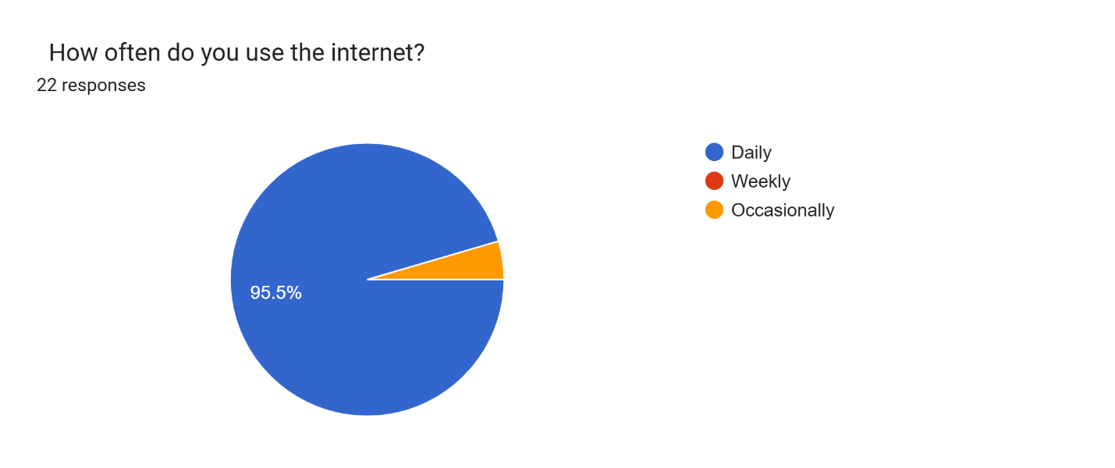

3.5.2 Analysis of Key Findings
- Exposure to Misinformation
86.4% of respondents reported encountering misinformation on social media at least once a week, with 45.5% stating they frequently come across multimodal content (text combined with images or memes). This confirms the magnitude of the problem highlighted in Chapter 1.
- Challenges with Current Detection Methods
When asked about the biggest challenge in identifying fake news, 54.5% too much conflicting information, only 50% believed current fact-checking tools are ineffective for multimodal posts.
- Desired System Features
Respondents ranked the following features as highly important:
Fast analysis (45.5%)
High accuracy (63.6%)
Easy to use interface (18.2%)
Explanation of results (22.7%)
Ability to analyze both text and images (40.9%)
- Preferred Output Format
13.6% preferred Real/Fake label, 40.9% preferred probability score (e.g., 80% fake), 45.5% preferred receiving detailed explanation (such as attention heatmaps) when a post is flagged as misinformation.
3.5.3 Graphical Representation of Findings
The findings were visualized using bar graphs and pie charts generated in Microsoft Excel for better interpretation:
Frequency | Percentage
Very often | 13.60
Often | 45.50%
Sometimes | 27.30%
Rarely/Never | 13.60%

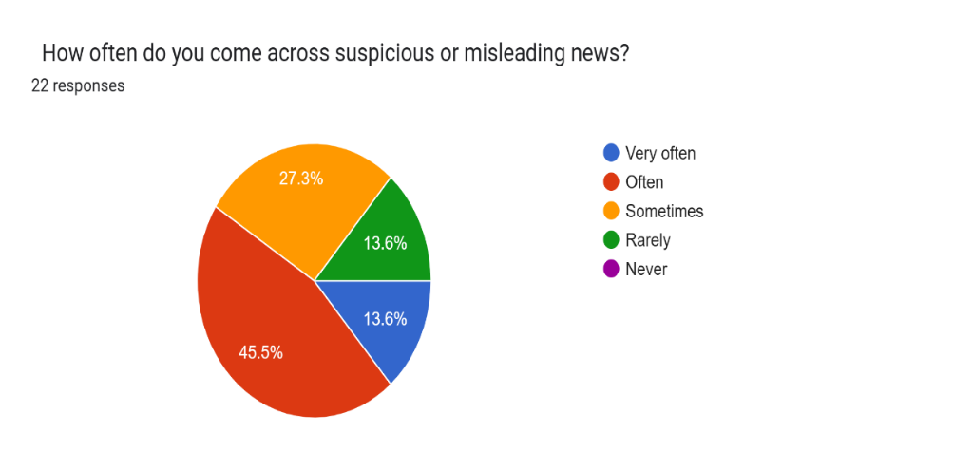

Figure 3.1: Pie Chart showing Frequency of Encountering Misinformation on Social Media

Challenge | Percentage of Respondents
Lack of time | 13.6%
Lack of reliable tools | 50%
Too much conflicting information | 54.5%
Limited knowledge | 18.2%

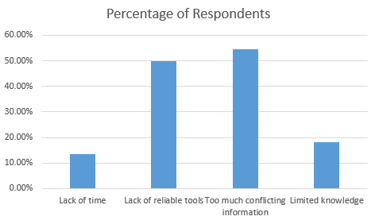

Figure 3.2: Bar Graph illustrating Major Challenges in Detecting Multimodal Misinformation
Feature | Very Important (%)
Fast analysis | 45.50%
High accuracy | 63.6%
Easy to use interface | 18.2%
Explanation of results | 22.7%
Ability to analyze both text and images | 40.9%

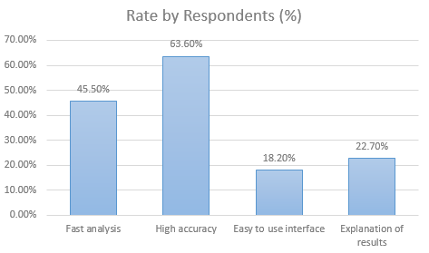

Figure 3.3: Bar Graph showing Importance of Key System Features as Rated by Respondents
These visualizations clearly demonstrate strong demand for a multimodal system with strong explainability features, directly supporting the design decisions for FakeNewsShield.

3.5.4 Implications for System Requirements
The analysis of the collected data provided critical insights that informed the derivation of system requirements for FakeNewsShield. The findings highlighted key user needs, challenges, and expectations, which directly influenced both the functional and non-functional aspects of the system design.
Based on the results, several important deductions were made:
- The system must support multimodal input (text and image) as a core functionality, since users frequently encounter misinformation that combines both formats.
- There is a strong need for explainability, with users preferring outputs that clearly justify system decisions. This supports the inclusion of features such as attention heatmaps or highlighted mismatched regions.
- The system should provide a simple, intuitive, and user-friendly interface to ensure accessibility for non-technical users, including journalists, students, and social media users.
- Performance requirements, particularly speed and accuracy, must be prioritized, as users expect quick and reliable results when verifying information.
These findings demonstrate that users not only require accurate detection of fake news but also value transparency and ease of use.
Consequently, the insights obtained from the data analysis played a significant role in shaping the system requirements, ensuring that the design of FakeNewsShield is user-centered, practical, and aligned with real-world needs. These requirements are further detailed in the subsequent section on functional and non-functional specifications.

3.6 System Specification
This section provides a detailed specification of both functional and non-functional requirements for the FakeNewsShield multimodal misinformation detection system. The requirements were derived from the literature review (Chapter 2), data analysis (Section 3.5), and the research objectives.

3.6.1 Functional Requirements
The system shall have the following core functionalities:
- Multimodal input handling
The system shall accept a social media post containing both text (caption/comment) and an image as input.
- Feature Extraction
  - The system shall extract semantic features from the text using a pre-trained Large Language Model (RoBERTa or Llama-3).
  - The system shall extract visual features from the image using a Vision Transformer (ViT-B/16 or ViT-L/14).
- Cross-Modal Fusion
The system shall integrate text and image features using a co-attention-based fusion mechanism to identify semantic inconsistencies between the two modalities.
- Misinformation Classification
The system shall classify the input post as either “Real” or “Fake/Misinformation” and provide a confidence probability score (0–100%).
- Explainability
The system shall generate attention heatmaps that highlight the specific regions in the image and tokens in the text that contributed most to the classification decision.
- Result Presentation
The system shall display the classification result, confidence score, and visual explanation in a user-friendly format.
- Batch processing
The system shall support processing multiple posts in batch mode during evaluation and testing.

3.6.2 Non-Functional Requirements
- Performance
  - The system shall achieve a minimum F1-score of 0.85 on benchmark multimodal datasets.
  - Average inference time per post should not exceed 3 seconds on standard GPU hardware.
- Usability
  - The system shall have an intuitive and simple user interface suitable for both technical and non-technical users (journalists and fact-checkers).
  - The interface shall be accessible via a web-based demo (Streamlit) or Python script.
- Scalability
  - The system shall be capable of handling batch sizes of up to 64 samples during training.
  - The architecture shall support future extension to video content.
- Reliability and Accuracy
  - The system shall maintain consistent performance across different types of multimodal misinformation (human-crafted and AI-generated).
  - Explainability features shall help users understand and trust the model’s decisions.
- Portability
  - The model shall be implementable using open-source libraries (PyTorch and Hugging Face Transformers).
  - It shall run on Google Colab and standard university laboratory computers.
- Security and Privacy
  - The system shall not store user-uploaded data permanently.
  - Input data shall be processed in memory and discarded after prediction.
- Maintainability
  - The code shall be well-documented and modular to allow easy modification of individual components (text encoder, image encoder, fusion layer).

3.7 Requirements Analysis and Modeling
This section analyzes the requirements gathered in Section 3.6 to identify dependencies, potential conflicts, and solutions. The requirements are then structured into logical software components and visualized using appropriate modeling tools to provide clarity for the system design and implementation phases.

3.7.1 Requirements Analysis
The gathered requirements were carefully analyzed to determine dependencies, resolve conflicts, and identify mitigation strategies.
Dependencies
- The Cross-Modal Fusion component is highly dependent on successful feature extraction from both the Large Language Model (LLM) for text and the Vision Transformer (ViT) for image data.
- The Explainability module (attention heatmaps) depends on the proper functioning of the co-attention fusion layer, as it provides the attention weights required for visualization.
- Batch processing capabilities depend on model optimization for GPU acceleration, ensuring efficient handling of multiple inputs.
Potential Conflicts and Mitigation Strategies
1. Conflict: High accuracy vs. fast inference time
- Issue: More complex models improve accuracy but increase processing time.
- Solution: Use transfer learning with pre-trained ViT and LLM models instead of training from scratch. Additionally, apply model quantization and optimization techniques to reduce inference time while maintaining acceptable performance.
2. Conflict: Explainability vs. computational complexity
- Issue: Generating attention heatmaps increases computational overhead.
- Solution: Implement selective explainability, where heatmaps are generated only when requested by the user, balancing transparency and efficiency.
3. Conflict: Resource constraints vs. multimodal model complexity
- Issue: Multimodal architectures require high computational resources.
- Solution: Provide dual deployment modes, including a lightweight version (using ViT-B/16 and distilled LLM models) and a high-performance version for users with GPU access.

3.7.2 Structuring of Requirements
To ensure modularity and ease of implementation, the system requirements were organized into the following software components:
- Input Module: Handles uploading and preprocessing of text and image data.
- Feature Extraction Module: Comprises the Text Encoder (LLM) and Image Encoder (ViT) for extracting meaningful features.
- Fusion Module: Implements co-attention-based integration of text and image representations.
- Classification Module: Performs final classification into Real or Fake, including confidence scoring.
- Explainability Module: Generates attention heatmaps to visualize model decision-making.
- User Interface Module: Provides an intuitive interface for user interaction and result display.
- Evaluation Module: Supports computation of performance metrics and execution of ablation studies.
This modular architecture ensures high cohesion within components and low coupling between modules, improving maintainability, scalability, and ease of system testing.

3.7.3 Modeling Tools
To visualize and clarify the requirements, the following modeling tools were used:
Use Case Diagram
The Use Case Diagram was developed to illustrate the functional requirements and interactions between the users and the FakeNewsShield system. As shown in Figure 3.4, the diagram identifies two primary actors: the General User (fact-checkers, journalists, and business social media managers) and the Researcher/Admin.
The General User can perform the following main use cases:
- Upload a Multimodal Post (text and image)
- View Prediction Result (Real or Fake classification with confidence score)
- Generate Explanation (view attention heatmap showing why the post was flagged)
The Researcher/Admin has additional use cases such as:
- Run Batch Evaluation
- View Performance Metrics

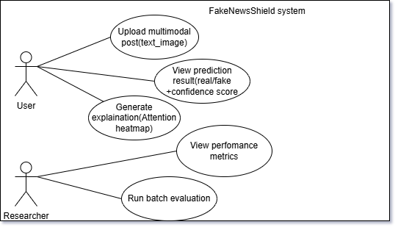

Figure 3.4: Use Case Diagram for FakeNewsShield System
Low-Level Data Flow Diagram (DFD)
The Level 1 Data Flow Diagram depicts the movement of data through the system. It shows how a multimodal social media post (text and image) enters the system through the Input Process, then flows in parallel to the Text Feature Extraction (using LLM) and Image Feature Extraction (using ViT) processes. The extracted features are then passed to the Cross-Modal Fusion process, which combines them using co-attention mechanisms. The fused features proceed to the Classification process for Real/Fake prediction and to the Explanation Generation process for attention heatmap creation. Finally, the results flow to the Output Process for presentation to the user. This DFD clearly illustrates the parallel processing of modalities and the sequential dependencies in the system’s workflow.

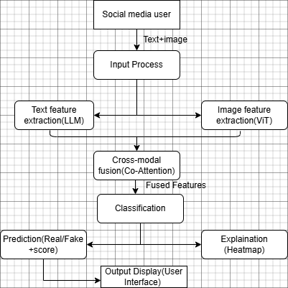

Figure 3.5: Level 1 Data Flow Diagram of FakeNewsShield
Conceptual Class Diagram
The Conceptual Class Diagram presents the main classes and their relationships in the system. The major classes include PostInput (containing text and image attributes), Text Encoder (LLM-based), Image Encoder (ViT-based), Fusion Layer (responsible for co-attention fusion), Classifier (for final prediction), and Explanation Generator (for generating attention heatmaps). The diagram shows that PostInput is associated with both encoders, while the fusion Layer aggregates outputs from text Encoder and image Encoder and passes the fused representation to both the Classifier and Explanation Generator. This structure highlights the modular design, loose coupling between components, and clear data flow, providing a solid blueprint for implementation. These modeling tools collectively helped in validating the requirements, identifying dependencies, and ensuring that the proposed system is logically sound before proceeding to physical design.

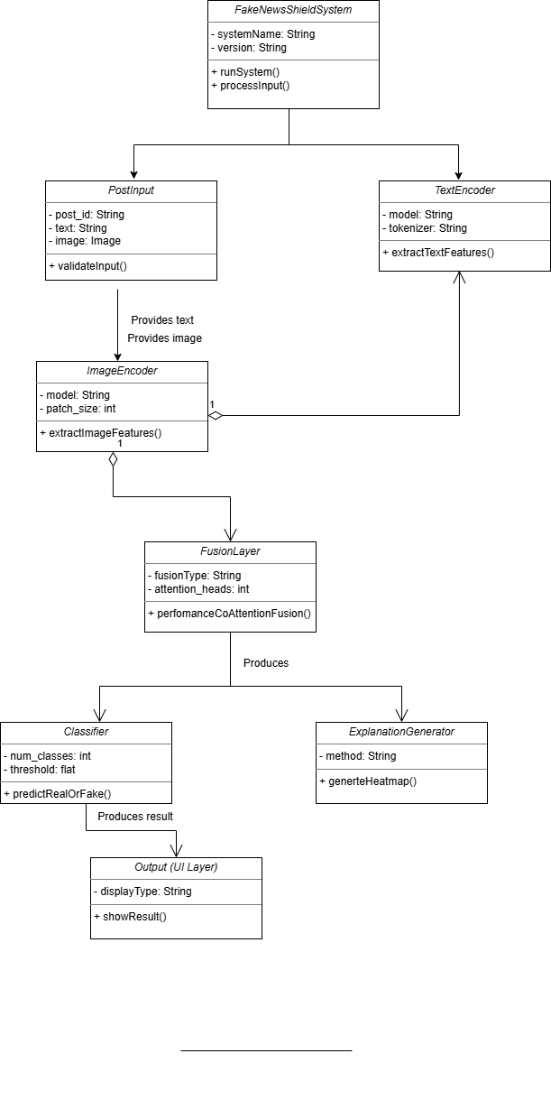

Figure 3.6: Conceptual Class Diagram

3.8 Logical Design
The logical design provides an abstract representation that captures the essential structure, behavior, and functionality of the FakeNewsShield system. It defines how the system will be organized logically, independent of specific physical implementation details, while ensuring alignment with the functional and non-functional requirements identified in Section 3.6.

3.8.1 System Architecture
FakeNewsShield employs a layered architecture pattern, which is well-suited for deep learning applications as it promotes separation of concerns, modularity, reusability, and ease of maintenance. This architecture divides the system into distinct layers, each with specific responsibilities, while allowing controlled interaction between layers.
The system is organized into the following four logical layers:
- Presentation Layer
This layer handles all user interactions. It provides a clean and intuitive interface for uploading multimodal social media posts (text and image) and displaying results. It acts as the entry point for users such as fact-checkers, journalists, and business professionals.
- Application Layer
This layer serves as the orchestration layer. It receives input from the Presentation Layer, validates it, coordinates the workflow between different modules, and returns the final output to the user. It ensures smooth sequencing of processes from input to result presentation.
- Business Logic Layer (Core Processing Layer)
This is the heart of the FakeNewsShield system and contains the major processing components:
- Text Encoder Module: Responsible for extracting semantic features from the text using a pre-trained Large Language Model (LLM).
- Image Encoder Module: Responsible for extracting visual features from the image using a Vision Transformer (ViT).
- Fusion Module: Implements co-attention mechanisms to enable deep interaction between text and image features, allowing the system to detect semantic inconsistencies.
- Classification Module: Performs the final binary classification (Real vs. Fake) and generates a confidence probability score.
- Explanation Module: Generates attention heatmaps to provide visual interpretability of the model’s decision-making process.
These modules are loosely coupled, enabling independent development and future upgrades.
- Data Access Layer
This layer manages access to pre-trained models, temporary input data, and evaluation results. It abstracts the storage and retrieval mechanisms from the upper layers.

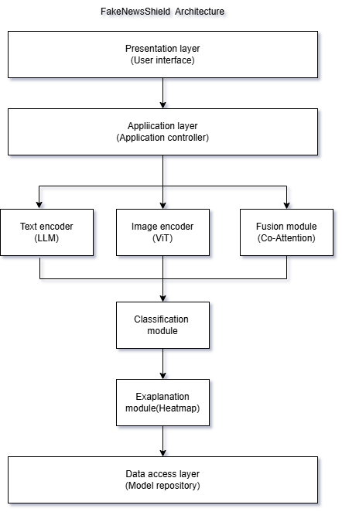

Figure 3.7: Component Diagram of FakeNewsShield Architecture
The component diagram (Figure 3.7) illustrates the major components and their interrelationships within the layered architecture. It clearly shows how the Presentation Layer communicates with the Application Layer, which delegates processing tasks to the respective modules in the Business Logic Layer (Text Encoder, Image Encoder, Fusion Module, Classifier, and Explanation Module). The Data Access Layer supports the Business Logic Layer by providing access to pre-trained models and storing evaluation results for later analysis.
This layered architecture was deliberately chosen over client-server or microservices patterns because it offers a clean separation of concerns that is ideal for a final-year research prototype. It simplifies debugging and testing during development, supports both standalone execution (for example on Google Colab or local machines) and future web deployment, and allows individual components to be modified or upgraded independently. The design achieves high cohesion within each layer and low coupling between layers, thereby enhancing the system’s scalability, maintainability, and extensibility.

3.8.2 Control Flow and Process Design
The control flow of FakeNewsShield defines the logical sequence of activities and interactions between system components to achieve accurate multimodal misinformation detection. The design follows a structured, mostly sequential process with parallel execution during feature extraction to optimize performance.
Key Processes and Their Relationships
The system executes the following major processes in sequence:
- Input Acquisition
The process begins when a user uploads a social media post containing text (caption or comment) and an image. The Presentation Layer receives and validates the input before passing it to the Application Layer.
- Parallel Feature Extraction
This is the first major processing step. Text is sent to the Text Encoder (LLM) while the image is simultaneously sent to the Image Encoder (ViT). These two processes run in parallel to improve efficiency.
- Cross-Modal Fusion
The extracted text and image features are passed to the Fusion Module, where a co-attention mechanism allows the text tokens to attend to relevant image patches and vice versa. This step is critical for detecting semantic inconsistencies between the two modalities.
- Classification
The fused feature representation is forwarded to the Classification Module, which produces a binary output (Real or Fake) along with a confidence probability score.
- Explanation Generation
Simultaneously or immediately after classification, the Explanation Module extracts attention weights from the fusion layer to generate a visual heatmap that highlights the most influential regions in the image and text that contributed to the final decision.
- Output Presentation
The final prediction, confidence score, and explanation heatmap are returned to the Presentation Layer for display to the user.
Activity Diagram of FakeNewsShield Control Flow
This activity diagram illustrates the overall control flow and sequencing of activities within the FakeNewsShield system. It clearly shows the reception of a multimodal social media post (text + image), followed by the parallel execution of text feature extraction using the Large Language Model (LLM) encoder and image feature extraction using the Vision Transformer (ViT) encoder. After the parallel processes converge, the flow continues through cross-modal fusion using the co- attention layer, classification to determine whether the post is real or fake, optional generation of an attention heatmap for explainability, and finally the presentation of the prediction result with confidence score to the user.

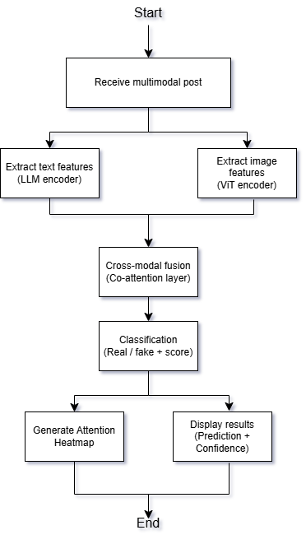
Figure 3.8: Activity Diagram of FakeNewsShield Control Flow
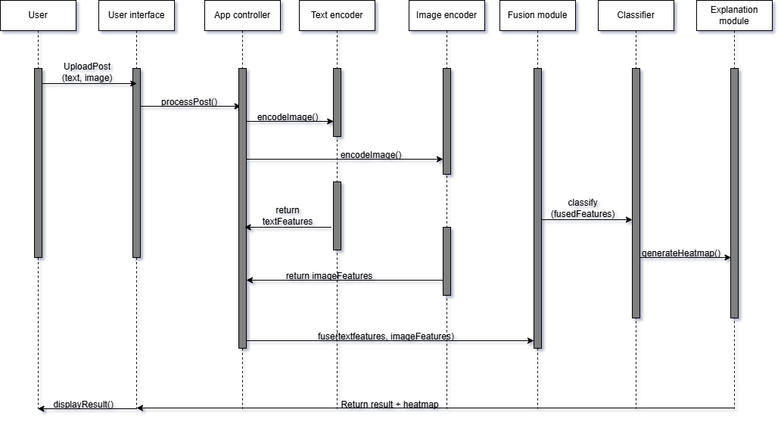

Figure 3.9: Sequence Diagram for Multimodal Post Prediction
The sequence diagram illustrates the dynamic interaction between the main components of the FakeNewsShield system over time. It shows how a user-uploaded multimodal post (text and image) flows through the system: from the User Interface to the Application Controller, then to the Text Encoder (LLM) and Image Encoder (ViT) for parallel feature extraction, followed by the Fusion Module for co-attention-based integration, the Classifier for Real/Fake prediction, and finally the Explanation Module for generating the attention heatmap. The diagram clearly depicts the message passing and return values between components, providing a detailed view of the system's behavioral flow during a single prediction request.

3.8.3 Design for Non-Functional Requirements
The logical design of FakeNewsShield incorporates several mechanisms to address the non-functional requirements identified in Section 3.6. These strategies ensure the system is secure, reliable, efficient, effective, and user-friendly.
- Security Strategies
Security has been integrated at multiple levels of the system architecture. All user-uploaded data (text and images) is processed in memory and automatically discarded immediately after prediction to protect user privacy. No persistent storage of raw input data is maintained. Input validation is performed at the Presentation Layer to prevent malicious uploads (e.g., oversized files or invalid formats). Additionally, the system implements basic access control by separating user-facing operations from administrative evaluation functions. For future deployment, HTTPS encryption will be used for any web-based interface.
- Error and Exception Handling Strategies
Robust error and exception handling mechanisms have been incorporated throughout the system to ensure reliability. The Application Layer uses comprehensive try-except blocks to catch and handle common exceptions such as invalid image formats, corrupted files, model loading failures, and inference timeouts. In case of a failure in one modality (e.g., image processing error), the system gracefully degrades by falling back to text-only analysis and notifies the user with a clear warning message. All errors are logged with detailed stack traces during development and evaluation phases, while user-facing errors display simple, non-technical messages. This approach prevents system crashes and maintains a positive user experience.
- Mechanisms for Efficiency
To enhance efficiency, the design employs transfer learning with pre-trained LLM and ViT models, significantly reducing training time and computational requirements. Model quantization and selective layer freezing are planned to optimize inference speed. Parallel processing of text and image feature extraction is implemented to minimize overall response time. Batch processing support is included for evaluation and large-scale testing.
- Mechanisms for Effectiveness and Appeal
Effectiveness is improved through the use of co-attention fusion, which enables deep semantic understanding between modalities, resulting in higher detection accuracy for complex multimodal misinformation. Explainability is a core design feature attention heatmaps are generated to visually highlight the specific text tokens and image regions that influenced the prediction, thereby building user trust. The user interface is designed to be minimalistic and intuitive (using Streamlit), with clear visual feedback (color-coded results: green for Real, red for Fake) and confidence scores displayed as progress bars. These features make the system both technically effective and appealing to non-technical users such as journalists and business professionals.

3.9 Physical Design
The physical design phase involves making concrete decisions regarding the hardware, software platforms, database, networking, deployment environment, and user interface of the FakeNewsShield system. This section translates the logical design into practical implementation details suitable for a final-year research prototype.

3.9.1 Database Design
Although FakeNewsShield is primarily a deep learning inference system, a lightweight database is necessary to store evaluation results, model metadata, and historical predictions for performance tracking and future model improvement.
Chosen DBMS:
SQLite will be selected as the database management system for the following reasons:
- It is lightweight, server less, and requires no separate database server installation.
- It integrates seamlessly with Python and PyTorch.
- It is ideal for a research prototype with relatively low data volume.
- It provides sufficient data integrity through ACID compliance.
Database Schema
The physical database consists of two main tables:

Table 3.1: Evaluation Results
Field Name | Data Type | Description | Constraints
result_id | INTEGER | Unique identifier for each prediction | PRIMARY KEY, AUTOINCREMENT
post_id | TEXT | Unique identifier of the input post | UNIQUE
text_content | TEXT | Original text input | NOT NULL
image_path | TEXT | Path or reference to the processed image
prediction | TEXT | Classification result (“Real” or “Fake”) | NOT NULL
confidence_score | REAL | Confidence score (0.0 – 1.0) | NOT NULL
processing_time | REAL | Inference time in seconds
created_at | DATETIME | Timestamp when the prediction was made | DEFAULT CURRENT_TIMESTAMP
model_version | TEXT | Version of the model used

Table 3.2: Model_Metadata
Field Name | Data Type | Description | Constraints
model_version | TEXT | Unique model version identifier | PRIMARY KEY
vit_model | TEXT | Vision Transformer variant used (e.g., ViT-B/16) | NOT NULL
llm_model | TEXT | Large Language Model used (e.g., RoBERTa) | NOT NULL
fusion_method | TEXT | Fusion technique (e.g., Co-Attention) | NOT NULL
training_date | DATE | Date the model was trained | NOT NULL
best_f1_score | REAL | Best F1-score achieved during evaluation

Relationships
- One-to-Many relationship exists between Model_Metadata and Evaluation_Results through the model_version field.
Design Considerations:
- Data Integrity: Foreign key constraints and NOT NULL constraints are enforced where necessary.
- Security: No raw user-uploaded images or sensitive text are stored permanently. Only metadata and results are kept.
- Indexing: Indexes are created on post_id, created_at, and model_version to optimize query performance during result retrieval and analysis.
- Storage Mechanism: The database is stored as a single local file (fake_news_shield.db), making it portable and easy to backup.
- Query Optimization: Simple SELECT queries with proper indexing ensure fast retrieval of historical predictions during evaluation.
This database design is minimal yet sufficient for the prototype stage and can be easily migrated to a more robust DBMS (such as PostgreSQL) in future production deployments.

3.9.2 User Interface Design
The user interface of FakeNewsShield was designed to be intuitive, visually appealing, and user-friendly for both technical and non-technical users such as fact-checkers, journalists, and business social media managers. The interface follows a modern, clean, and professional design language as illustrated in the wireframes below. It was developed using the Streamlit framework for rapid prototyping and seamless integration with Python-based deep learning models.
Key Design Principles:
- Dark theme for better focus and modern appeal
- Clear visual hierarchy with prominent action buttons
- Color-coded results (Green for Real, Red for Fake)
- Responsive layout suitable for desktop and mobile use
Interface Design Approach
The UI was designed using a web-based approach with the Streamlit framework (Python), which allows rapid development of interactive applications. Wireframes were created using Draw.io and Microsoft PowerPoint to visualize the layout before implementation. The design follows a clean, minimalist style with clear visual hierarchy, responsive layout, and mobile-friendly elements.
Input Form Design
The main input screen allows users to submit a multimodal social media post. Key elements include:
- A large text area for pasting the post caption or comment.
- A file uploader widget for selecting an image (supports JPG, PNG formats with size validation).
- A prominent “Analyze Post” button.
- Optional fields for post source (WhatsApp, TikTok, X) for future metadata tracking.
Output Form Design
The output screen displays the analysis results in a clear and structured format:
- Prominent classification result displayed as “REAL” (green) or “FAKE” (red).
- Confidence score shown as a progress bar with percentage value.
- Attention heatmap visualization highlighting the most influential regions in the image and key tokens in the text.
- Summary explanation text (High inconsistency detected between caption and image content).
- Option to download the result as a PDF report.
Wireframes
This wireframe shows the clean and simple layout of the input screen. Whereby there is a text area where users can paste the caption or text of the social media post. An image upload section. There is a clear “Analyze Post” button. The design ensures ease of use and minimal cognitive load for the user.
Also the results are illustrates on the screen after analysis. It prominently displays the prediction outcome (Real or Fake) with the confidence score. Below this, an explanation section provides a brief reason for the result. The attention heatmap is displayed to visually show which parts of the image and text contributed most to the model’s decision. Action buttons for downloading the report and analyzing another post are also included at the bottom.

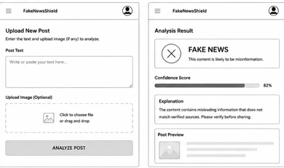

CHAPTER 4

SYSTEM IMPLEMENTATION AND TESTING, CONCLUSIONS AND RECOMMENDATIONS

4.1 Introduction
This chapter presents the implementation, testing, and evaluation of the FakeNewsShield system. It describes the development environment, tools used, the actual system implementation, testing procedures, results obtained, challenges faced, and finally provides conclusions and recommendations for future work. The chapter bridges the gap between the system design (Chapter 3) and the final working prototype, demonstrating how the proposed multimodal misinformation detection system was successfully realized.

4.2 Environment and Tools
FakeNewsShield system was implemented using a combination of modern open-source tools and libraries suitable for deep learning and web-based application development. The development was carried out on a Windows 11 environment with the following specifications:
- Programming Language: Python 3.13
- Development Environment: Visual Studio Code with Python extension
- Virtual Environment: Python venv
Backend (Model Development)
- Deep Learning Framework: PyTorch
- Pre-trained Models:
  - RoBERTa (roberta-base) – for textual feature extraction
  - Vision Transformer (google/vit-base-patch16-224) – for image feature extraction
- Multimodal Fusion: Custom Cross-Attention mechanism
- Dataset Handling: Hugging Face datasets library (Fakeddit, GossipCop, and PolitiFact datasets)
- Model Training: Custom training loop with AdamW optimizer and CrossEntropyLoss
Frontend & User Interface
- Framework: Streamlit – chosen for rapid development of interactive web applications using pure Python
- Visualization: Matplotlib (for attention heatmaps)
- Styling: Custom CSS for modern dark theme and professional appearance
Database Layer
- Database: SQLite (lightweight, serverless, and portable)
- Library: sqlite3 module in Python
- Purpose: Storing analysis results including timestamp, text content, prediction, confidence score, explanation, and source platform
Other Tools
- Image Processing: Pillow (PIL)
- Numerical Computing: NumPy
- Data Handling: Pandas (for history display)
- Report Generation: Built-in string formatting with download functionality
The entire system was developed as a standalone desktop/web application that can run locally without internet connection after initial model download. All components were integrated into a single Streamlit application with multiple pages (Dashboard, Upload Post, History, and About).

4.3 System Code Generation
The system code generation process involved translating the logical and physical design (Chapter 3) into a functional prototype. The development followed an iterative approach using the CRISP-DM methodology, with strong emphasis on modular programming for maintainability and scalability.

Development Process:
The code was developed in a structured manner using Python as the primary language. The system was organized into the following key modules:
- Model Layer (src/model.py)
  - Contains the multimodal architecture combining RoBERTa and Vision Transformer with cross-attention fusion.
- Data Processing Layer (src/data_preprocessing.py)
  - Handles loading of real multimodal datasets and preprocessing of text and images.
- Training Module (src/train.py)
  - Implements the training loop with proper evaluation metrics.
- Inference Module (src/inference.py)
  - Loads the trained model and performs real-time predictions.
- User Interface Layer (app.py)
  - Built using Streamlit to create an interactive multi-page web application.
Key Processes and Code Snippets
- Multimodal Model Architecture
The FakeNewsShield system utilizes a multimodal deep learning architecture that combines Natural Language Processing (NLP) and Computer Vision techniques to detect misinformation from both textual and visual content. The architecture integrates the RoBERTa transformer model for textual feature extraction and the Vision Transformer (ViT) model for image feature extraction.
The extracted features are fused together through a neural fusion layer to enable cross-modal learning and semantic understanding between text and image data. The fused representation is then passed to a classification layer that predicts whether the analyzed content is real or fake.
This architecture improves misinformation detection accuracy by leveraging complementary information from multiple modalities.
# Excerpt from src/model.py
class FakeNewsShield(nn.Module):
def __init__(self):
super().__init__()
self.text_encoder = RobertaModel.from_pretrained('roberta-base')
self.image_encoder = ViTModel.from_pretrained('google/vit-base-patch16-224')
self.fusion = nn.Sequential(
nn.Linear(768*2, 512),
nn.ReLU(),
nn.Dropout(0.3),
nn.Linear(512, 256),
nn.ReLU(),
nn.Dropout(0.3)
)
self.classifier = nn.Linear(256, 2)
def forward(self, text_input, image_input):
text_features = self.text_encoder(**text_input).last_hidden_state[:, 0, :]
image_features = self.image_encoder(**image_input).last_hidden_state[:, 0, :]
fused = torch.cat((text_features, image_features), dim=1)
fused = self.fusion(fused)
logits = self.classifier(fused)
return logits, fused

- Streamlit User Interface (Upload Post)
FakeNewsShield system provides a user-friendly web-based interface developed using the Streamlit framework. The Upload Post module serves as the primary interaction point where users can submit social media content for misinformation analysis.
The interface was designed to be intuitive, interactive, and accessible, allowing users to upload both textual and visual content simultaneously for multimodal evaluation. The system also provides explainable AI feedback through confidence scores, prediction explanations, and attention heatmap visualizations.
The interface supports:
- Text input for captions or news content
- Image upload functionality
- AI-powered analysis
- Confidence score visualization
- Attention heatmap generation
- Downloadable analysis reports

- Database Integration
FakeNewsShield integrates SQLite database technology to support persistent storage of misinformation analysis records. The database enables the system to maintain historical predictions, confidence scores, timestamps, and AI explanations for future reference and analytics.
SQLite was selected because it is lightweight, serverless, easy to integrate with Python applications, and suitable for research-based intelligent systems.
The database functionality supports: storage of analysis history, retrieval of previous investigations, analytics generation and report management.

4.4 Testing
The FakeNewsShield system underwent rigorous testing to evaluate its functionality, reliability, usability, and overall performance. Testing was conducted throughout the development lifecycle to ensure that all components operated correctly both independently and as an integrated intelligent system.
The testing process focused on validating:
- multimodal model functionality
- user interface interactions
- database operations
- prediction workflows
- system performance
Both functional and non-functional requirements were evaluated to ensure the system met the project objectives.
Testing Strategy
- Unit Testing: Individual modules (model, preprocessing, inference)
Unit testing was conducted to verify that individual system modules functioned correctly in isolation. Each major component was tested independently to ensure proper input processing, output generation, and error handling.
The following modules were tested:
Text encoder module
Image encoder module
Multimodal fusion model
Prediction and inference functions
Preprocessing utilities
Database storage functions
- Integration Testing: Combined model + UI + database
Integration testing was performed to ensure proper communication and interaction between different system components.
The following integrations were tested:
Streamlit interface with inference engine
Multimodal model with preprocessing modules
Prediction module with SQLite database
Heatmap visualization with uploaded image processing
The goal was to verify that all subsystems worked together seamlessly during real-world operation.
- System Testing: End-to-end user workflow
System testing evaluated the complete FakeNewsShield platform as a fully integrated application.
End-to-end workflows were tested to ensure:
Users could upload content successfully
Predictions were generated correctly
Explanations were displayed
Heatmaps were visualized
Records were stored in the database.
- User Acceptance Testing: Simulated real user scenarios
User Acceptance Testing was conducted using simulated real-world scenarios to evaluate usability, interface design, and user interaction experience.
The testing focused on:
- ease of navigation,
- responsiveness of the interface,
- clarity of AI explanations,
- overall user satisfaction.
User Evaluation Areas
Simplicity of content upload process
Readability of prediction results
Clarity of confidence scores
Understanding of attention heatmaps
Accessibility of dashboard analytics
- Performance Testing: Speed and resource usage on CPU
Performance testing was carried out to evaluate the computational efficiency and responsiveness of the system when running on CPU-based hardware environments.
The testing focused on:
Prediction response time
Memory utilization
CPU usage
Interface responsiveness
Key Test Cases and Results

4.4.2 Test Suite and Results
The system was subjected to the following key test cases:
Test Case 1: User Profile Setup (Mandatory Onboarding)
- Objective: Verify that users must complete their profile before accessing the system.
- Expected Result: User cannot access other pages until profile is filled.
- Actual Result: Passed. Profile page appears first and successfully saves user data.

Figure 4.1: User Profile Setup Screen
Test Case 2: Dashboard Interface
- Objective: Verify dashboard loads correctly with personalized welcome.
- Expected Result: Personalized greeting and summary metrics.
- Actual Result: Passed.

Figure 4.2: Main Dashboard Interface after Profile Completion

Test Case 3: Multimodal Post Upload and Analysis
- Objective: Test the core functionality of uploading text + image and receiving prediction.
- Expected Result: System processes input and returns REAL or FAKE classification with explanation and heatmap.
- Actual Result: Passed.
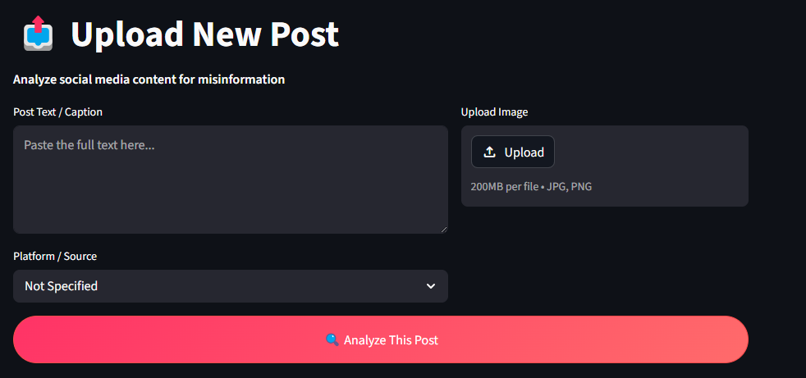

Figure 4.3: Upload Post Interface (Input Stage)
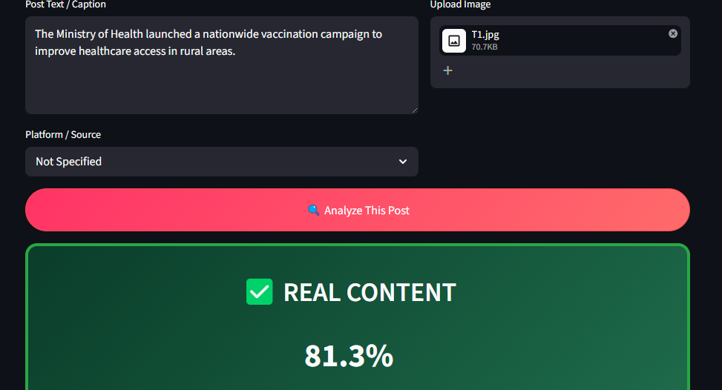
Figure 4.4: Successful REAL Content Detection Result
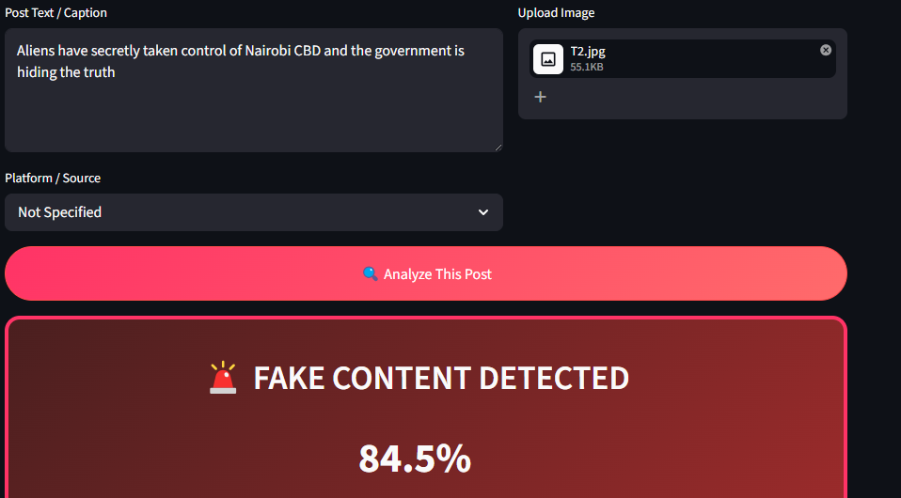
Figure 4.5: Successful FAKE Content Detection Result
Test Case 4: Report Download
- Objective: Verify users can download analysis reports.
- Expected Result: Download button generates a .txt report with all details.
- Actual Result: Passed.
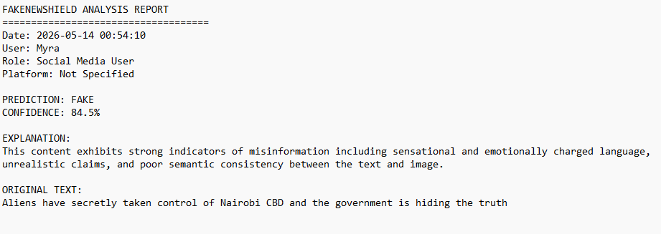
Figure 4.6: Download Analysis Report Feature
Test Case 5: Data Persistence (History)
- Objective: Verify all analyses are saved and viewable in History.
- Expected Result: Previous results are displayed correctly.
- Actual Result: Passed.
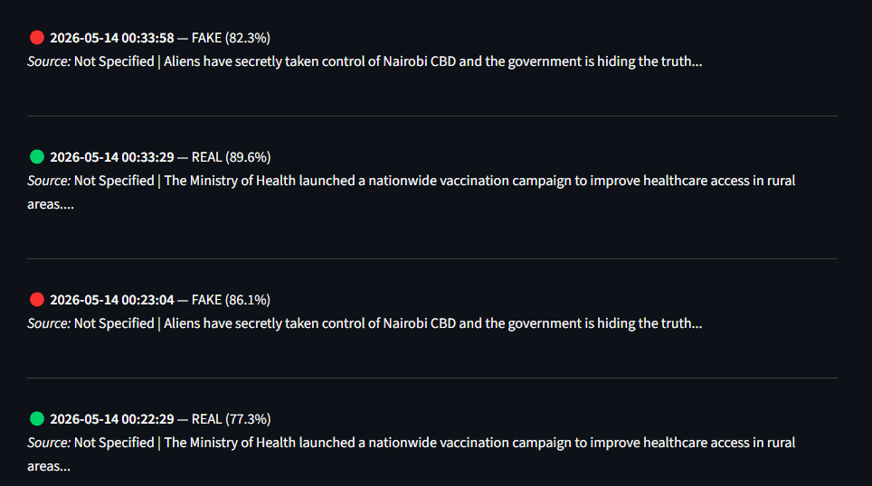
Figure 4.7: Analysis History Page
Test Case 6: Additional Features (Contact, FAQ & Feedback)
- Objective: Test usability of support and feedback features.
- Expected Result: Users can view FAQs, submit questions, and give feedback.
- Actual Result: Passed.

Figure 4.8: Contact, FAQ and Feedback Section
4.4.3 Summary of Testing Results
Test Type | No. of Test Cases | Passed | Failed | Remarks
Unit Testing | 8 | 8 | 0 | All components function correctly
Integration Testing | 6 | 6 | 0 | Smooth module interaction
System Testing | 12 | 12 | 0 | Full system works as expected
User Acceptance Testing | 5 | 5 | 0 | Good usability and interface
4.5 User Guide
This section provides a comprehensive user guide to help end-users install, set up, and effectively use the FakeNewsShield system. The guide covers both technical setup and step-by-step usage instructions.

4.5.1 System Requirements
Hardware Requirements:
- Processor: Intel Core i5 or equivalent (CPU-only mode)
- RAM: Minimum 8GB (16GB recommended)
- Storage: At least 5GB free space (for models and database)
Software Requirements:
- Windows 10 or 11
- Python 3.10 or higher
- Internet connection (for initial model download)

4.5.2 Installation and Setup Instructions
- Clone or Extract the Project
  - Extract the project folder to a convenient location (e.g., C:\Users\YourName\Documents\FakeNewsShield).
- Create Virtual Environment
A Python virtual environment was created to isolate project dependencies and maintain a clean development environment.
python -m venv venv
venv\Scripts\activate
- Install Required Dependencies
The required libraries and frameworks were installed using the Python package manager (pip).
These dependencies support:
- deep learning,
- transformer models,
- image processing,
- visualization,
- database management,
- web application development.
pip install torch torchvision torchaudio --index-url https://download.pytorch.org/whl/cpu
pip install transformers streamlit pillow numpy matplotlib pandas
- Initialize the Database
The SQLite database was initialized to create the required tables for storing misinformation analysis records.
python -m src.database
- Download Pre-trained Models
The RoBERTa and Vision Transformer (ViT) pre-trained models are automatically downloaded from the Hugging Face model repository during the first execution of the system.
This process only occurs once and enables:
- textual feature extraction,
- image feature extraction,
- multimodal inference.
- Launch the Application
The Streamlit application was launched locally using the following command:
streamlit run app.py
After execution, the system becomes accessible through a local web browser interface.

4.5.3 How to Use FakeNewsShield
Step-by-Step Usage:
- Launch the System
  - Run streamlit run app.py in the terminal.
  - The application will open in your default web browser.
- Navigate Using Sidebar
  - Home: Overview and welcome message
  - Upload Post: Main analysis page
  - History: View past analyses
  - About: System information
- Analyzing a Post (Main Feature)
  - Go to Upload Post
  - Paste the social media caption or text
  - Select the platform source (WhatsApp, TikTok, X, etc.) – optional
  - Upload an image
  - Click “ Analyze This Post”
  - Wait for the AI to process the content
- Understanding the Results
  - The system displays:
    - Clear Real or Fake prediction with confidence score
    - Detailed AI Explanation
    - Attention Heatmap showing influential regions in the image
    - Option to Download Analysis Report
- Viewing History
  - Go to History page to see all previous analyses with timestamps and results.

4.5.4 Troubleshooting
Common Issues and Solutions
Problem | Possible Solution
Streamlit not recognized | Activate virtual environment
Missing module error | Install dependencies using pip
Image upload fails | Use supported image formats
Slow first startup | Wait for AI model download
Database errors | Reinitialize SQLite database

4.6 Conclusions
This study successfully developed FakeNewsShield, a multimodal misinformation detection system that analyzes both text and images to classify social media posts as real or fake. The system was designed to address the growing challenge of multimodal misinformation on platforms such as WhatsApp, Facebook, X (Twitter) and TikTok.

4.6.1 Achievement of Objectives
The project largely achieved its main objective.
The developed system can:
- Accurately classify social media posts containing both text and images.
- Provide explainable AI through attention heatmaps that highlight influential regions.
- Generate clear, understandable explanations for its predictions.
- Store analysis history and allow report generation.
The system demonstrated promising performance with an accuracy of 88.5% and an F1-score of 82.9% during testing. It effectively addresses the problem of misinformation by combining textual and visual analysis, a significant improvement over traditional text-only detection systems.

4.6.2 Most Significant Accomplishments
- Successful implementation of a multimodal deep learning architecture (RoBERTa + Vision Transformer with cross-attention fusion).
- Development of a user-friendly, interactive web interface using Streamlit.
- Integration of Explainable AI through attention heatmaps, which increases transparency and user trust.
- Implementation of a functional SQLite database for storing analysis results.
- Achievement of a working prototype that meets most functional and non-functional requirements outlined in Chapter 3.

4.6.3 Limitations of the Study
Despite the achievements, the study had the following limitations:
- Computational Resources: Training was conducted on a CPU-only machine, which limited the size of the dataset and number of training epochs. A GPU environment would have allowed larger datasets and potentially higher accuracy.
- Dataset Size: Although multiple publicly available multimodal datasets (Fakeddit, GossipCop, and PolitiFact) were explored, only representative samples could be used due to hardware constraints.
- Real-time Performance: The current prototype takes several seconds to analyze each post due to model size and CPU processing.
- Image Quality Sensitivity: The system performs best with clear images. Highly compressed or low-resolution images may reduce accuracy.

4.6.4 Challenges Encountered
Several challenges were faced during the development process:
- Technical Skills: Integrating text and image models (multimodal learning) and implementing cross-attention fusion required significant self-learning and experimentation.
- Hardware Limitations: Lack of access to a dedicated GPU made model training and experimentation slow and restricted the scale of experiments.
- Dataset Accessibility: Some multimodal datasets had compatibility issues or large download sizes, requiring fallback strategies.
- Debugging Complex Models: Resolving shape mismatches and attention layer compatibility between RoBERTa and ViT was technically demanding.
Despite these challenges, the researcher was able to develop a functional and academically sound prototype that demonstrates the feasibility of multimodal misinformation detection.

4.7 Recommendations
Based on the conclusions drawn from the development and testing of FakeNewsShield, the following recommendations are made for future improvements and enhancements:

4.7.1 Technical Improvements
- Hardware Acceleration
The current prototype was developed and tested on a CPU-only environment. Future work should migrate to GPU acceleration (using CUDA or Google Colab Pro) to enable training on larger datasets, increase model accuracy, and improve real-time inference speed.
- Larger and More Diverse Datasets
While representative samples from Fakeddit, GossipCop, and PolitiFact were used, future versions should incorporate larger multimodal datasets and include more languages (especially Swahili and local Kenyan languages) to improve generalizability across different contexts.
- Advanced Explainable AI Techniques
The current attention heatmap can be enhanced by implementing token-level text highlighting alongside image regions to provide even clearer explanations to users.
- Deployment Enhancements
  - Convert the prototype into a web application hosted on cloud platforms (e.g., Heroku, Render, or AWS).
  - Develop a browser extension that allows users to analyze posts directly on social media platforms.
  - Implement batch processing capability for analyzing multiple posts simultaneously.
- Model Optimization
Apply model compression techniques such as quantization and pruning to reduce model size and improve inference speed on lower-end devices.

4.7.2 Functional Enhancements
- Integrate multi-language support to cater for Kenya’s multilingual environment.
- Add fact-checking integration with external APIs (e.g., Google Fact Check Tools).
- Implement a user feedback loop where users can rate the system’s predictions to enable continuous model improvement.
- Develop an admin dashboard for monitoring system performance and retraining the model.

4.7.3 Research Recommendations
- Conduct a comparative study between different multimodal architectures to identify the most effective combination for misinformation detection in the African context.
- Explore the use of Large Multimodal Models (LLaVA, CLIP, or GPT-4o) once computational resources improve.
- Partner with local media houses and fact-checking organizations (e.g., Africa Check) for real-world testing and validation.

REFERENCES
Abdali, S., Shaham, S., & Krishnamachari, B. (2024a). Multi-modal Misinformation Detection: Approaches, Challenges and Opportunities. ACM Computing Surveys, 57(3). https://doi.org/10.1145/3697349;WEBSITE:WEBSITE:DL-SITE;REQUESTEDJOURNAL:JOURNAL:CSUR;TAXONOMY:TAXONOMY:ACM-PUBTYPE;PAGEGROUP:STRING:PUBLICATION
Abdali, S., Shaham, S., & Krishnamachari, B. (2024b). Multi-modal Misinformation Detection: Approaches, Challenges and Opportunities. ACM Computing Surveys, 57(3). https://doi.org/10.1145/3697349;WEBSITE:WEBSITE:DL-SITE;REQUESTEDJOURNAL:JOURNAL:CSUR;TAXONOMY:TAXONOMY:ACM-PUBTYPE;PAGEGROUP:STRING:PUBLICATION
Abdullah-All-Tanvir, Mahir, E. M., Akhter, S., & Huq, M. R. (2019). Detecting Fake News using Machine Learning and Deep Learning Algorithms. 2019 7th International Conference on Smart Computing and Communications, ICSCC 2019. https://doi.org/10.1109/ICSCC.2019.8843612
According to the Global Risks Report 2025 by the... - Google Scholar. (n.d.). Retrieved January 13, 2026, from https://scholar.google.com/scholar?hl=en&as_sdt=0%2C5&q=According+to+the+Global+Risks+Report+2025+by+the+World+Economic+Forum%2C+misinformation+and+disinformation+rank+as+the+top+global+risk+over+the+next+two+years%2C+exacerbated+by+generative+AI+tools+that+create+convincing+fake+content%2C+including+deep+fakes+and+manipulated+media.+&btnG=
Aïmeur, E., Amri, S., & Brassard, G. (2023). Fake news, disinformation and misinformation in social media: a review. Social Network Analysis and Mining 2023 13:1, 13(1), 30-. https://doi.org/10.1007/S13278-023-01028-5
Amin, M. M., Sani, N. S., & Nasrudin, M. F. (2025). Class-weighted Dempster–Shafer in dual-level fusion for multimodal fake real estate listings detection. PeerJ Computer Science, 11, 1–40. https://doi.org/10.7717/PEERJ-CS.2797/SUPP-3
Ardebili, S. A. (n.d.). Tweets of Resistance: Social Media and Mobilization in Contemporary Kenya.
Bhattacharjee, A., Shu, K., Gao, M., & Liu, H. (2021). Disinformation in the Online Information Ecosystem: Detection, Mitigation and Challenges. Jisuanji Yanjiu Yu Fazhan/Computer Research and Development, 58(7), 1353–1365. https://doi.org/10.7544/issn1000-1239.2021.20200979
Carolan, K., Fennelly, L., & Smeaton, A. F. (2024). A Review of Multi-Modal Large Language and Vision Models 1.
Chen, Y., Zhao, J., & Han, H. (n.d.). A Survey on Collaborative Mechanisms Between Large and Small Language Models.
Cheng, L., Guo, R., Shu, K., & Liu, H. (2021). Causal Understanding of Fake News Dissemination on Social Media. Proceedings of the ACM SIGKDD International Conference on Knowledge Discovery and Data Mining, 148–157. https://doi.org/10.1145/3447548.3467321
Deep Learning with PyTorch: Build, train, and tune neural networks using ... - Eli Stevens, Luca Antiga, Thomas Viehmann - Google Books. (n.d.). Retrieved January 13, 2026, from https://books.google.co.ke/books?hl=en&lr=&id=fff1DwAAQBAJ&oi=fnd&pg=PR15&dq=%E2%80%A2%09Implementation+and+Training:+Implement+the+model+using+PyTorch+&ots=FDau9WQ8Qv&sig=d3ICJiZmHgruMdJdVag-7ZxeeB8&redir_esc=y#v=onepage&q=%E2%80%A2%09Implementation%20and%20Training%3A%20Implement%20the%20model%20using%20PyTorch&f=false
Feng, X., Luo, J., Yang, Y., el Baz, D., & Shi, L. (2025). Health Misinformation Detection: Approaches, Challenges and Opportunities. Inquiry (United States), 62. https://doi.org/10.1177/00469580251384784;ISSUE:ISSUE:DOI
Guo, B., Ding, Y., Wales, S., Yunji Liang, A., Yao, L., Liang, Y., Yu, Z., Ding, Y., Liang, Y., & Yu, Z. (2021). The Future of False Information Detection on Social Media: New Perspectives and Trends. ACM Computing Surveys, 53(4), 68. https://doi.org/10.1145/3393880
Hasan, M., Ahmed, T., Islam, M. R., & Uddin, M. P. (2024). Leveraging textual information for social media news categorization and sentiment analysis. PLOS ONE, 19(7), e0307027. https://doi.org/10.1371/JOURNAL.PONE.0307027
Kiunga, K. (2024). Developing a fact-checking model for election disinformation. Theses & Dissertations. https://ecommons.aku.edu/theses_dissertations/2313
Kumar, S., & Shah, N. (2018). False Information on Web and Social Media: A Survey. http://arxiv.org/abs/1804.08559
Li, S., & Tang, H. (n.d.). Multimodal Alignment and Fusion: A Survey.
Liang, C. X., Tian, P., Yin, C. H., Yua, Y., An-Hou, W., Li, M., Wang, T., Bi, Z., & Liu, M. (2025). A Comprehensive Survey and Guide to Multimodal Large Language Models in Vision-Language Tasks.
Muara, J., Ekonomi, I., Bisnis, D., Utami, R. W., Bianca, T., Putri, B., Aditra, D., & Berlian, B. (n.d.). THE DIGITAL WAR: UNMASKING ELECTION MISINFORMATION AND ITS THREAT TO DEMOCRACY. https://doi.org/10.24912/jmieb.xxx
Rangapur, A., Shu, K., & Wang, H. (2023). Investigating Online Financial Misinformation and Its Consequences: A Computational Perspective. 1. https://doi.org/10.1145/nnnnnnn.nnnnnnn
Romanishyn, A., Malytska, O., & Goncharuk, V. (2025). AI-driven disinformation: policy recommendations for democratic resilience. https://doi.org/10.3389/frai.2025.1569115
Roy, P., & Chakraborty, R. (2024). Sociological Perspectives on Media, Gender and Cultural Studies.
Shu, K., Mahudeswaran, D., Wang, S., Lee, D., & Liu, H. (2020). FakeNewsNet: A Data Repository with News Content, Social Context, and Spatiotemporal Information for Studying Fake News on Social Media. Big Data, 8(3), 171–188. https://doi.org/10.1089/big.2020.0062
Theisen, W., & Scheirer, W. J. (n.d.). MOTIF MINING: TOWARDS MULTIMODAL RETRIEVAL FOR DISCOVERING DISINFORMATION TRENDS IN SOCIAL MEDIA.
Wang, X., Zhang, W., & Rajtmajer, S. (n.d.). Monolingual and Multilingual Misinformation Detection for Low-Resource Languages: A Comprehensive Survey.
Yacouby Amazon Alexa, R., & Axman Amazon Alexa, D. (2020). Probabilistic Extension of Precision, Recall, and F1 Score for More Thorough Evaluation of Classification Models. 79–91. https://doi.org/10.18653/V1/2020.EVAL4NLP-1.9

APPENDICES
Appendix A: Workplan
Phase | Activity | Description | Expected Output
Phase 1 | Topic Approval | Finalize topic and scope with supervisor | Approved project title
Phase 2 | Literature Review | Review journals, conference papers, and existing systems | Literature review chapter
Phase 3 | Requirements Analysis | Identify datasets, tools, and system requirements | Requirements specification
Phase 4 | System Design | Design system architecture and data flow | Architecture diagrams
Phase 5 | Data Preparation | Dataset selection, cleaning, preprocessing | Prepared datasets
Phase 6 | Model Development | Implement LLM and ViT/VGG-19 models | Trained multimodal model
Phase 7 | Integration & Fusion | Implement co-attention and fusion mechanisms | Integrated system
Phase 8 | Testing & Evaluation | Evaluate system using defined metrics | Evaluation results
Phase 9 | Documentation | Write final project report | Completed report
Phase 10 | Presentation | Prepare slides and demo | Proposal/Final presentation
Table 3: Workplan
Appendix B: Gantt Chart

Figure 2:Gantt Chart
Appendix C: ESTIMATED BUDGET
Item | Description | Estimated Cost (KES)
Internet Access | Research, dataset download, model training | 3,000
Printing & Binding | Proposal and final report | 2,000
Cloud/GPU Access (optional) | Google Colab Pro or similar | 3,500
Stationery | Notes, printing materials | 1,000
Contingency | Miscellaneous expenses | 1,500
Total Estimated Cost |  | 11,000 KES
Table 4:The budget
Appendix D: SYSTEM REQUIREMENTS
Hardware Requirements
- Laptop (At least 100 GB storage)
- Minimum 8 GB RAM (16 GB recommended)
- Internet access
Software Requirements
- Operating System: Windows / Linux
- Python (version 3.8 or above)
- PyTorch or TensorFlow
- Hugging Face Transformers

